

Lab Report

|  |  |  |  |  |  |  |
| --- | --- | --- | --- | --- | --- | --- |
| **Only for course Teacher** | | | | | | |
|  | | **Needs Improvement** | **Developing** | **Sufficient** | **Above Average** | **Total Mark** |
| **Allocate mark & Percentage** | | **25%** | **50%** | **75%** | **100%** | **25** |
| **Understanding/Analysis** | **7** |  |  |  |  |  |
| **Implementation** | **8** |  |  |  |  |  |
| **Report Writing** | **10** |  |  |  |  |  |
| **Total obtained mark** | | | | | |  |
| **Comments** |  | | | | | |

**Semester: Spring 2025 Student Name:**

**Marwan Hossain**

**Team Member:**

**Marwan Hossain**

**Student ID:**

**0242310005341076**

**Batch: 41 Section: I**

**Course Code: SE224 Course Name: Database Systems Lab**

**Course Teacher Name: Liza Akter**

**Designation: Lecturer Submission Date: 15/04/2024**

EventSync – Personalized Event Planning & Management System

**Introduction**

The EventSync – Personalized Event Planning & Management System is a comprehensive event management platform designed to streamline the process of planning, organizing, and managing events. It serves as a centralized solution for various users such as organizers, attendees, and vendors. By managing user registrations, event schedules, venue bookings, vendor assignments, and expenses, the system enhances efficiency and communication among all participants. The database structure of EventSync provides a reliable backend foundation to ensure all operations are smoothly executed and data integrity is maintained.

**Task Information**

The primary task of this system is to manage the event lifecycle effectively. This includes:

* Registration of users as organizers, attendees, or vendors.
* Creation and management of events.
* Booking venues for specific events.
* Tracking event expenses.
* Managing vendor services and assignments.
* Monitoring attendee participation and confirmations.
* Enabling communication and coordination between various entities.

These functionalities are implemented using SQL through data definition language (DDL) and data manipulation language (DML) queries, as well as views and stored procedures for dynamic data handling.

**Attribute Information and Data Types**

|  |  |  |  |
| --- | --- | --- | --- |
| Table Name | Attribute | Data Type | Description |
| Users | user_id | INT,  AUTO_INCREMENT, PRIMARY KEY | Unique user identifier |
| Users | name | VARCHAR(100), | Name of the user |

|  |  |  |  |
| --- | --- | --- | --- |
|  |  | NOT NULL |  |
| Users | email | VARCHAR(100), UNIQUE, NOT NULL | Email address of the user |
| Users | password_hash | VARCHAR(255), NOT NULL | Encrypted password |
| Users | role | ENUM('Organizer', 'Attendee', 'Vendor') | Role assigned to the user |
| Events | event_id | INT,  AUTO_INCREMENT, PRIMARY KEY | Unique event identifier |
| Events | organizer_id | INT, NOT NULL | Foreign key referencing  Users(user_id) |
| Events | event_name | VARCHAR(255), NOT NULL | Title of the event |
| Events | event_date | DATETIME, NOT  NULL | Date and time of the  event |
| Events | venue_id | INT | Foreign key  referencing Venues(venue_id) |
| Events | budget | DECIMAL(10,2) | Budget allocated for the event |
| Attendees | attendee_id | INT,  AUTO_INCREMENT, PRIMARY KEY | Unique identifier for attendee records |
| Attendees | event_id | INT, NOT NULL | Foreign key referencing  Events(event_id) |
| Attendees | user_id | INT, NOT NULL | Foreign key  referencing Users(user_id) |
| Attendees | status | ENUM('Invited', 'Confirmed',  'Declined') | Attendance status |
| Venues | venue_id | INT,  AUTO_INCREMENT, PRIMARY KEY | Unique venue identifier |
| Venues | venue_name | VARCHAR(255), NOT NULL | Name of the venue |
| Venues | location | VARCHAR(255), NOT NULL | Venue location |
| Venues | capacity | INT, NOT NULL | Number of people the venue can hold |
| Bookings | booking_id | INT,  AUTO_INCREMENT, PRIMARY KEY | Unique booking identifier |
| Bookings | event_id | INT, NOT NULL | Foreign key referencing  Events(event_id) |

|  |  |  |  |
| --- | --- | --- | --- |
| Bookings | venue_id | INT, NOT NULL | Foreign key  referencing Venues(venue_id) |
| Bookings | booking_date | DATETIME, NOT NULL | Date when the venue was booked |
| Vendors | vendor_id | INT, AUTO_INCREMENT,  PRIMARY KEY | Unique vendor identifier |
| Vendors | vendor_name | VARCHAR(255), NOT NULL | Name of the vendor |
| Vendors | service_type | VARCHAR(100) | Type of service  provided |
| Vendors | contact_info | VARCHAR(255) | Contact details of the vendor |
| Expenses | expense_id | INT, AUTO_INCREMENT,  PRIMARY KEY | Unique expense identifier |
| Expenses | event_id | INT, NOT NULL | Foreign key  referencing Events(event_id) |
| Expenses | description | VARCHAR(255), NOT NULL | Description of the expense |
| Expenses | amount | DECIMAL(10,2), NOT NULL | Amount spent on the expense |
| Vendor_Assignment | assignment_id | INT, AUTO_INCREMENT,  PRIMARY KEY | Unique assignment identifier |
| Vendor_Assignment | vendor_id | INT, NOT NULL | Foreign key referencing  Vendors(vendor_id) |
| Vendor_Assignment | event_id | INT, NOT NULL | Foreign key  referencing Events(event_id) |
| Vendor_Assignment | assigned_date | DATE | Date when the vendor was  assigned |

**Conclusion**

The EventSync – Personalized Event Planning & Management System provides a structured and scalable solution to modern event management challenges. The system leverages SQL to perform complex queries and maintain relational integrity, ensuring smooth interaction between users, events, venues, vendors, and financial operations. With a normalized database design and robust query support, EventSync delivers a powerful backend infrastructure capable of supporting both small and large-scale events efficiently.

-- DATABASE CREATION CREATE DATABASE EventSync;

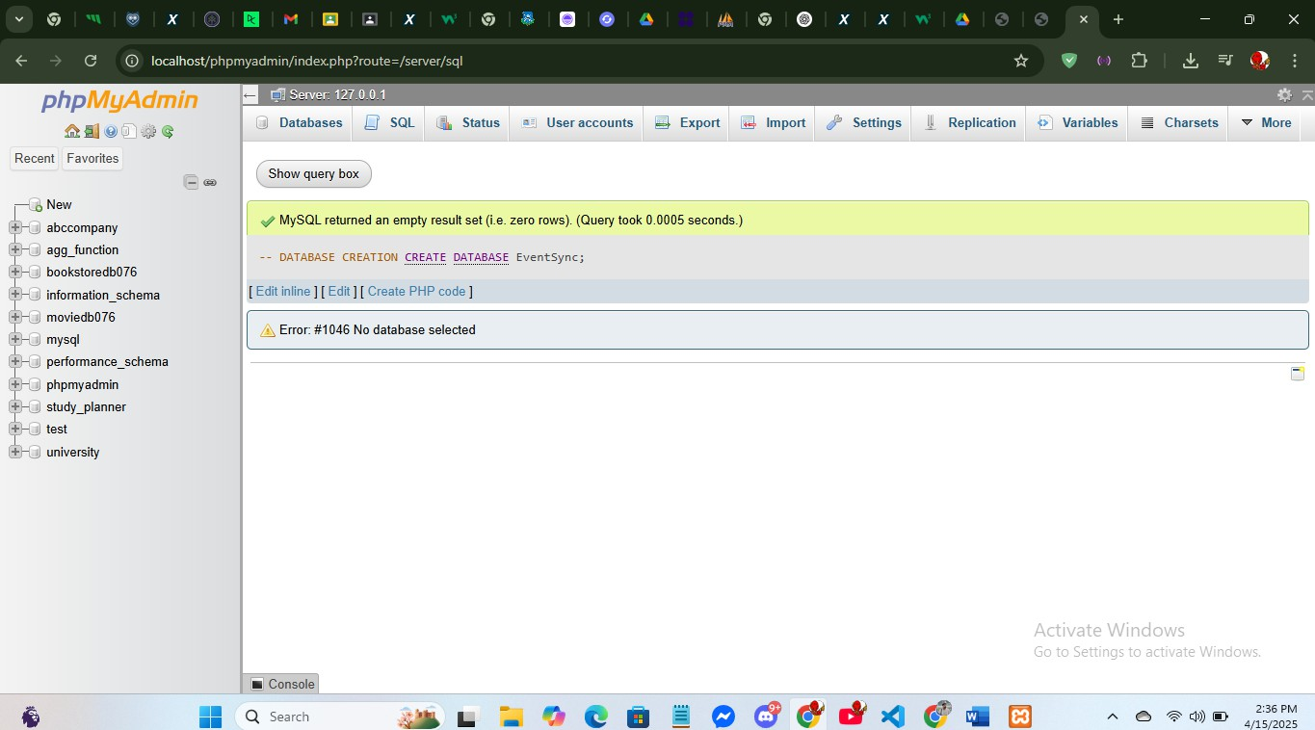

-- USERS TABLE CREATE TABLE Users (

user_id INT AUTO_INCREMENT PRIMARY KEY, name VARCHAR(100) NOT NULL,

email VARCHAR(100) UNIQUE NOT NULL,

password_hash VARCHAR(255) NOT NULL,

role ENUM('Organizer', 'Attendee', 'Vendor') NOT NULL

);

-- VENUES TABLE CREATE TABLE Venues (

venue_id INT AUTO_INCREMENT PRIMARY KEY,

venue_name VARCHAR(255) NOT NULL, location VARCHAR(255) NOT NULL,

capacity INT NOT NULL

);

-- EVENTS TABLE CREATE TABLE Events (

event_id INT AUTO_INCREMENT PRIMARY KEY,

organizer_id INT NOT NULL, event_name VARCHAR(255) NOT NULL, event_date DATETIME NOT NULL, venue_id INT,

budget DECIMAL(10,2),

FOREIGN KEY (organizer_id) REFERENCES Users(user_id),

FOREIGN KEY (venue_id) REFERENCES Venues(venue_id) ON DELETE SET NULL

);

-- ATTENDEES TABLE

CREATE TABLE Attendees (

attendee_id INT AUTO_INCREMENT PRIMARY KEY, event_id INT NOT NULL,

user_id INT NOT NULL,

status ENUM('Invited', 'Confirmed', 'Declined') DEFAULT 'Invited',

FOREIGN KEY (event_id) REFERENCES Events(event_id) ON DELETE CASCADE, FOREIGN KEY (user_id) REFERENCES Users(user_id) ON DELETE CASCADE

);

-- VENDORS TABLE

CREATE TABLE Vendors (

vendor_id INT AUTO_INCREMENT PRIMARY KEY,

vendor_name VARCHAR(255) NOT NULL, service_type VARCHAR(100), contact_info VARCHAR(255)

);

-- BOOKINGS TABLE

CREATE TABLE Bookings (

booking_id INT AUTO_INCREMENT PRIMARY KEY,

event_id INT NOT NULL, venue_id INT NOT NULL,

booking_date DATETIME NOT NULL,

FOREIGN KEY (event_id) REFERENCES Events(event_id) ON DELETE CASCADE, FOREIGN KEY (venue_id) REFERENCES Venues(venue_id) ON DELETE CASCADE

);

-- EXPENSES TABLE

CREATE TABLE Expenses (

expense_id INT AUTO_INCREMENT PRIMARY KEY,

event_id INT NOT NULL,

description VARCHAR(255) NOT NULL, amount DECIMAL(10,2) NOT NULL,

FOREIGN KEY (event_id) REFERENCES Events(event_id) ON DELETE CASCADE

);

-- VENDOR_ASSIGNMENT TABLE

CREATE TABLE Vendor_Assignment (

assignment_id INT AUTO_INCREMENT PRIMARY KEY, vendor_id INT NOT NULL,

event_id INT NOT NULL,

FOREIGN KEY (vendor_id) REFERENCES Vendors(vendor_id), FOREIGN KEY (event_id) REFERENCES Events(event_id)

);

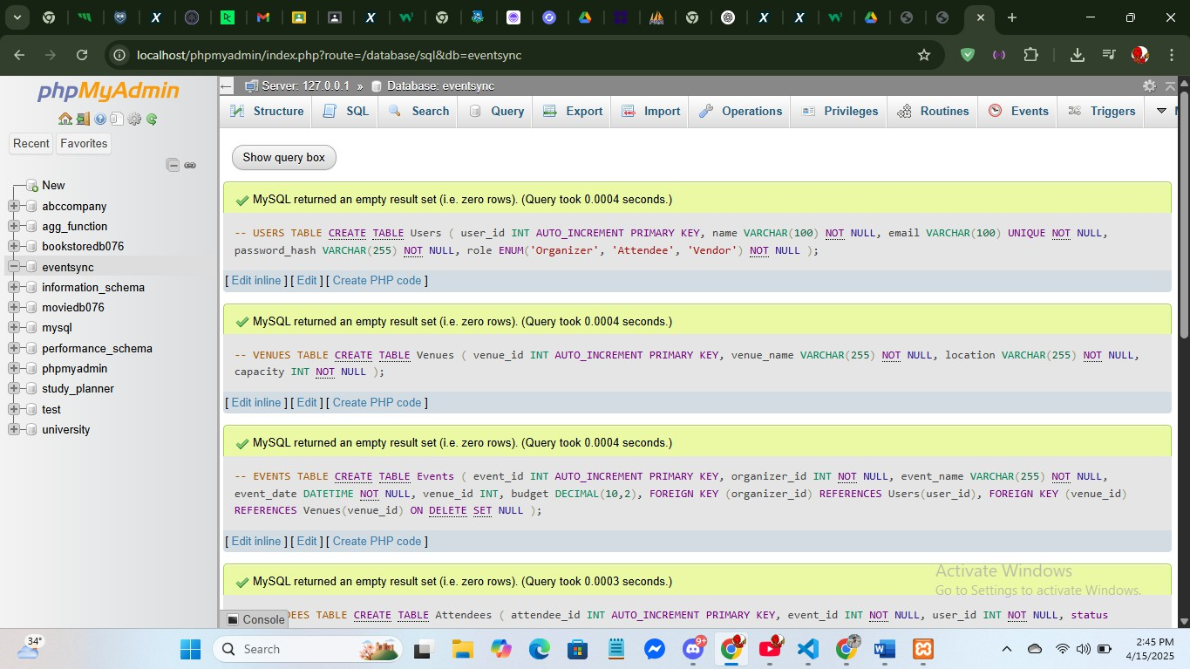

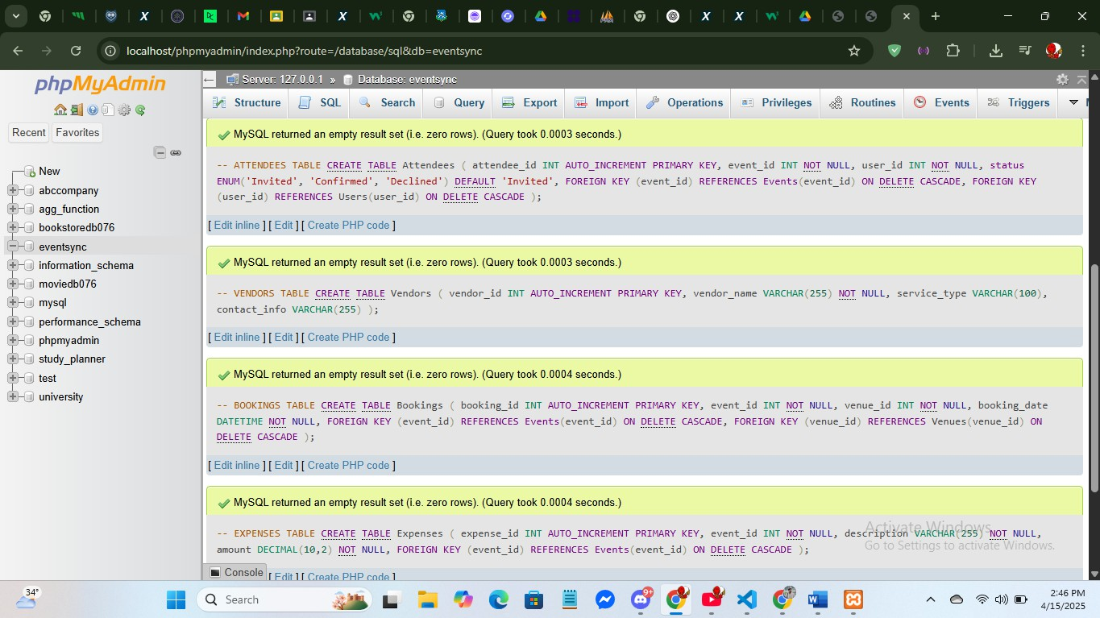

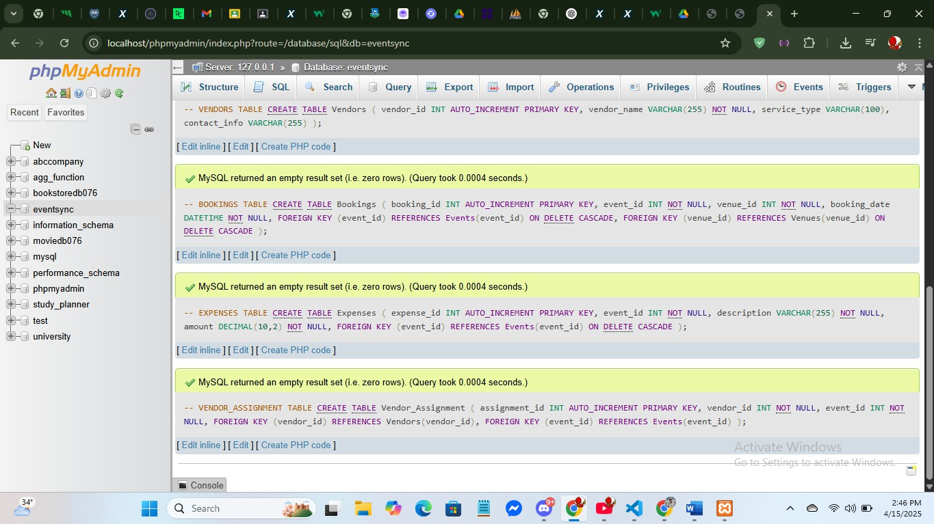

-- Insert into Users

INSERT INTO Users (name, email, password_hash, role) VALUES ('Alice Smith', ['alice@example.com',](mailto:%27alice@example.com) 'hashed_pass_1', 'Organizer'), ('Bob Johnson', ['bob@example.com',](mailto:%27bob@example.com) 'hashed_pass_2', 'Attendee'), ('Carol Davis', ['carol@example.com',](mailto:%27carol@example.com) 'hashed_pass_3', 'Vendor'), ('David Lee', ['david@example.com',](mailto:%27david@example.com) 'hashed_pass_4', 'Attendee'), ('Eve Brown', ['eve@example.com',](mailto:%27eve@example.com) 'hashed_pass_5', 'Organizer');

-- Insert into Venues

INSERT INTO Venues (venue_name, location, capacity) VALUES ('Grand Hall', 'Dhaka', 500),

('City Convention Center', 'Chittagong', 800), ('Open Garden Venue', 'Sylhet', 300), ('Skyline Rooftop', 'Dhaka', 150),

('Beachside Pavilion', 'Cox’s Bazar', 400);

-- Insert into Events (organizer_id must match Users with role='Organizer')

INSERT INTO Events (organizer_id, event_name, event_date, venue_id, budget) VALUES (1, 'Tech Conference 2025', '2025-05-20 10:00:00', 1, 100000.00),

(5, 'Wedding Expo', '2025-06-10 15:00:00', 2, 75000.00),

(1, 'Startup Meetup', '2025-07-05 17:00:00', 3, 30000.00),

(5, 'Food Fest', '2025-08-15 12:00:00', 4, 50000.00),

(1, 'Music Night', '2025-09-01 19:00:00', 5, 60000.00);

-- Insert into Attendees

INSERT INTO Attendees (event_id, user_id, status) VALUES

(1, 2, 'Confirmed'),

(1, 4, 'Invited'),

(2, 2, 'Confirmed'),

(3, 4, 'Declined'),

(4, 2, 'Confirmed');

-- Insert into Vendors

INSERT INTO Vendors (vendor_name, service_type, contact_info) VALUES ('Event Decor Ltd.', 'Decoration', ['decor@example.com'),](mailto:%27decor@example.com)

('Sound Masters', 'Audio/Visual', ['sound@example.com'),](mailto:%27sound@example.com) ('Foodies Catering', 'Catering', ['catering@example.com'),](mailto:%27catering@example.com) ('SecureX', 'Security', ['secure@example.com'),](mailto:%27secure@example.com) ('StageLight Co.', 'Lighting', ['light@example.com');](mailto:%27light@example.com)

-- Insert into Bookings

INSERT INTO Bookings (event_id, venue_id, booking_date) VALUES (1, 1, '2025-04-15 09:00:00'),

(2, 2, '2025-04-16 10:00:00'),

(3, 3, '2025-04-17 11:00:00'),

(4, 4, '2025-04-18 12:00:00'),

(5, 5, '2025-04-19 13:00:00');

-- Insert into Expenses

INSERT INTO Expenses (event_id, description, amount) VALUES (1, 'Venue rent', 20000.00),

(1, 'Audio setup', 15000.00),

(2, 'Decoration', 12000.00),

(3, 'Marketing', 8000.00),

(4, 'Security services', 7000.00);

-- Insert into Vendor_Assignment

INSERT INTO Vendor_Assignment (vendor_id, event_id) VALUES (1, 1),

(2, 1),

(3, 2),

(4, 4),

(5, 5);

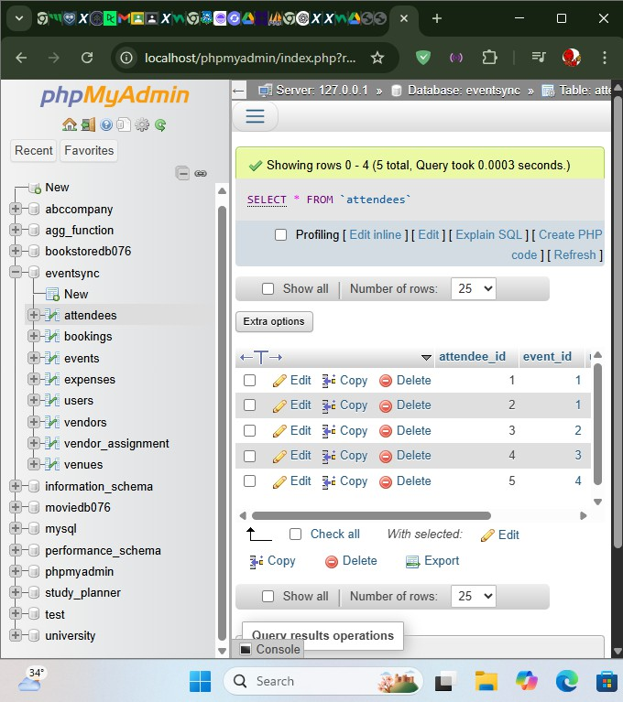

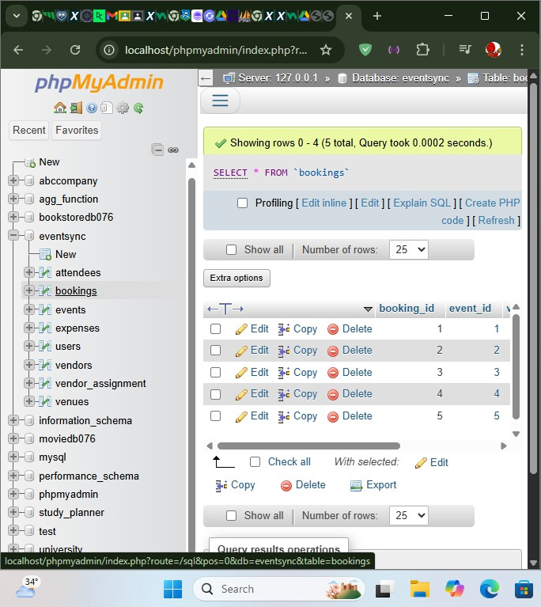

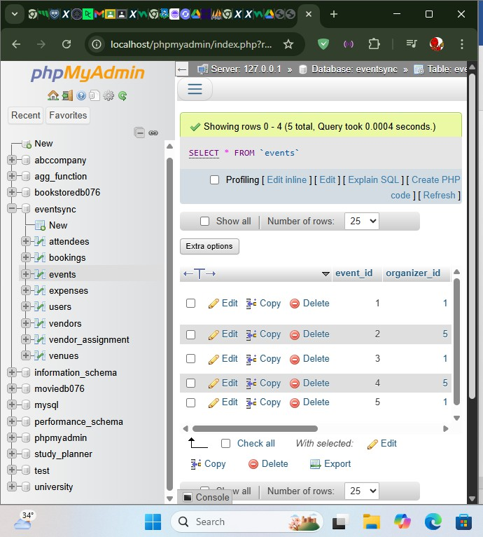

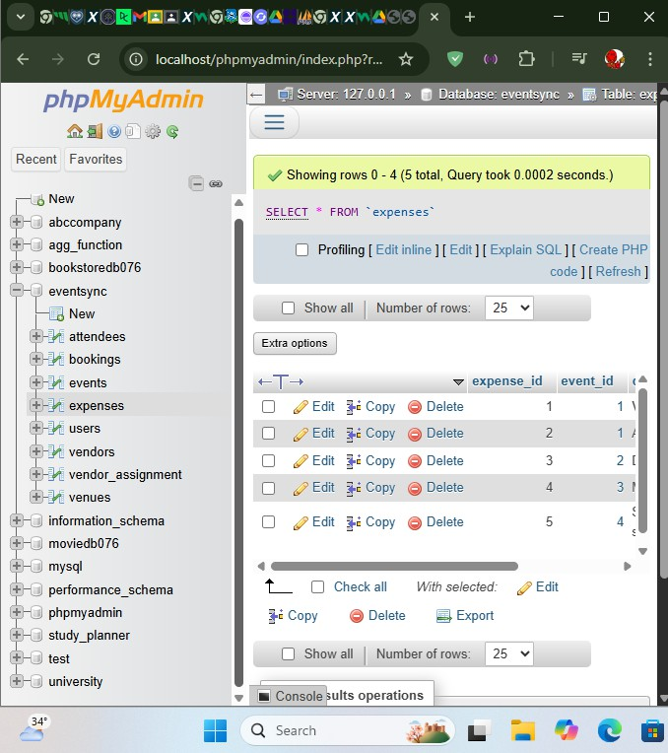

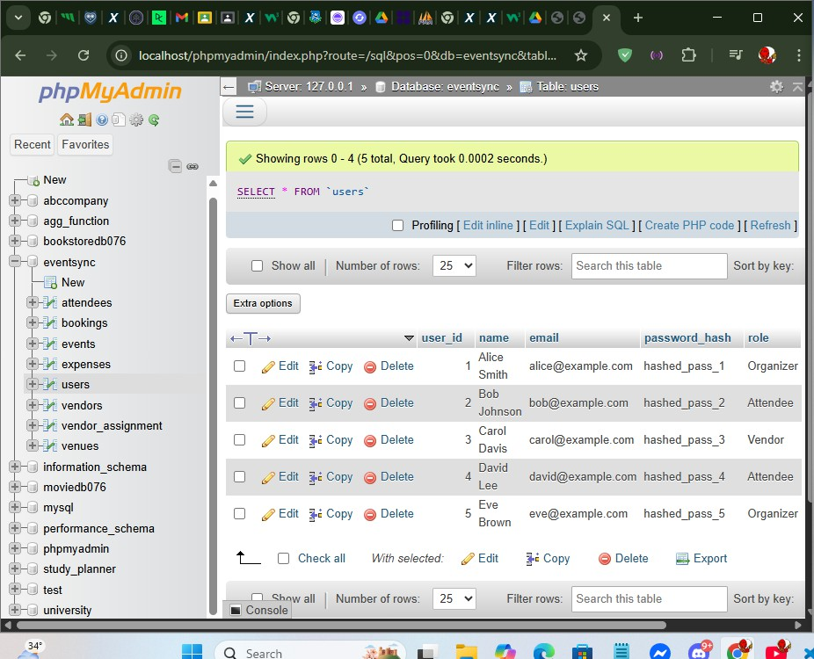

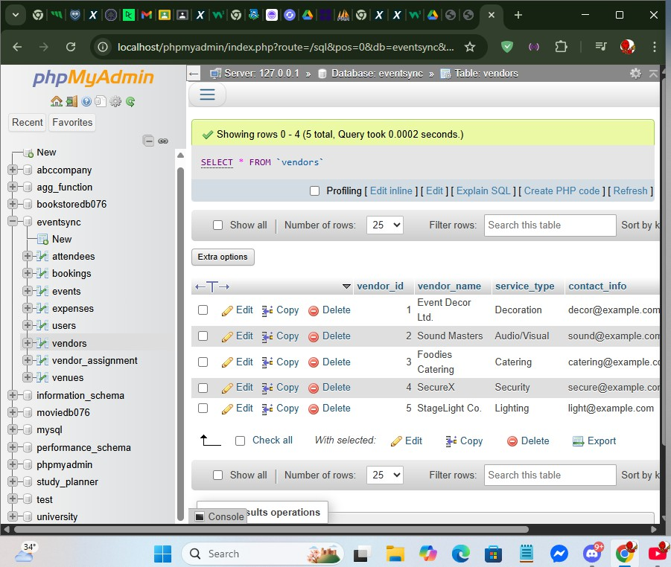

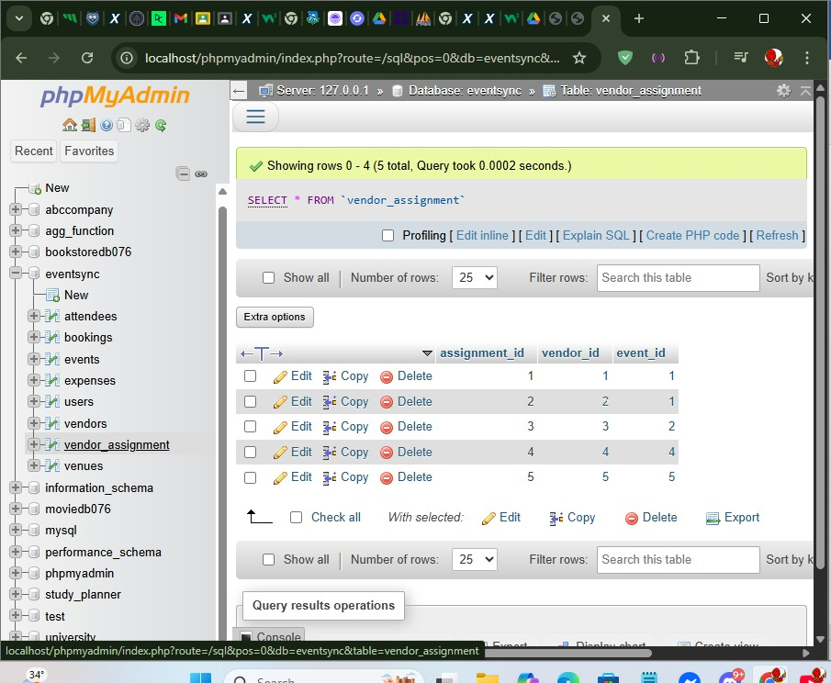

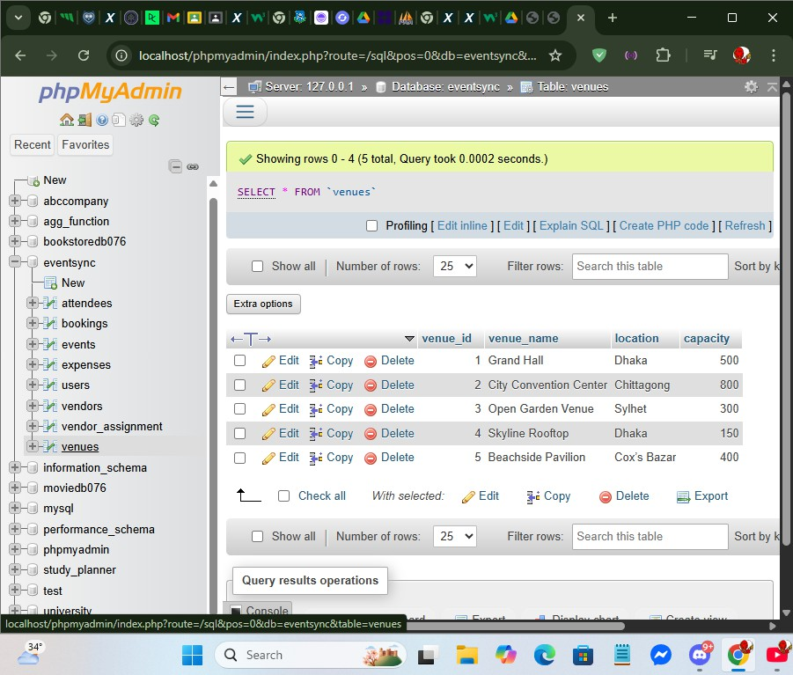

-- 1. Retrieve all users SELECT * FROM Users;

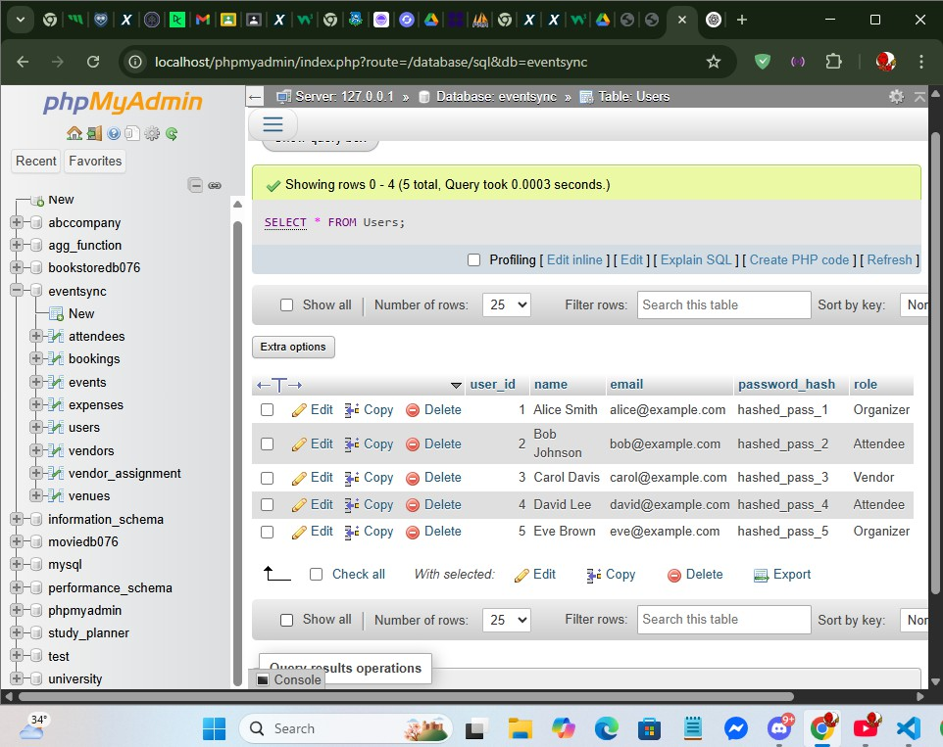

-- 2. Insert a new event

INSERT INTO Events (organizer_id, event_name, event_date, venue_id, budget) VALUES (1, 'Tech Conference', '2025-05-10 09:00:00', 2, 10000.00);

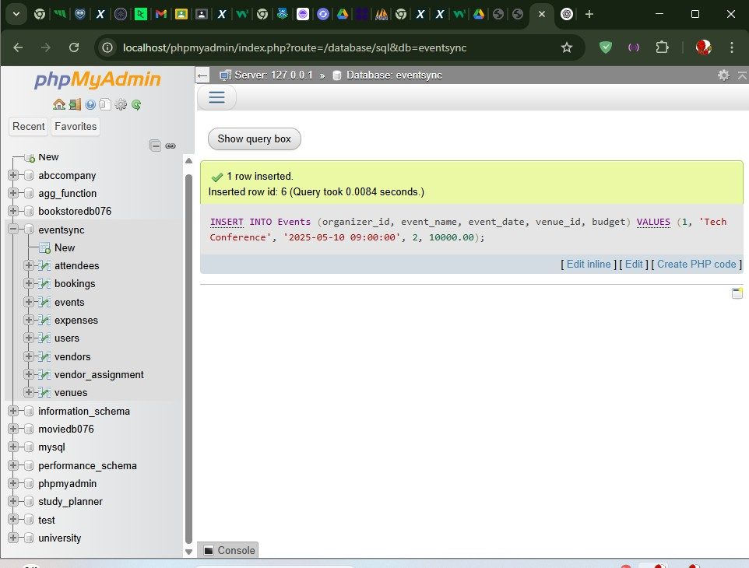

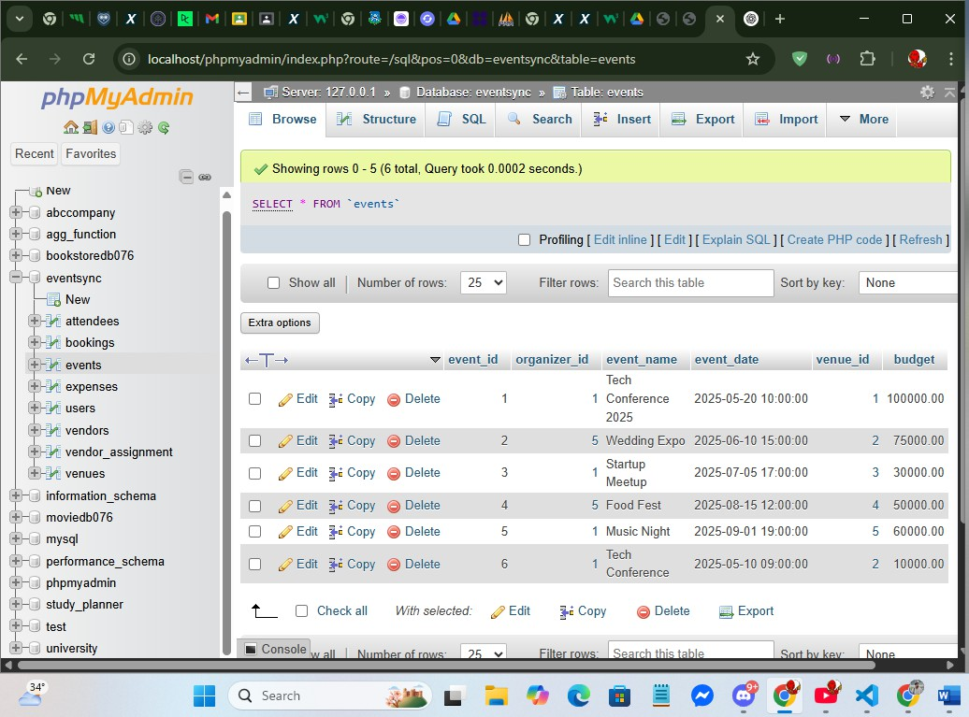

-- 3. Update event budget UPDATE Events

SET budget = 12000.00 WHERE event_id = 1;

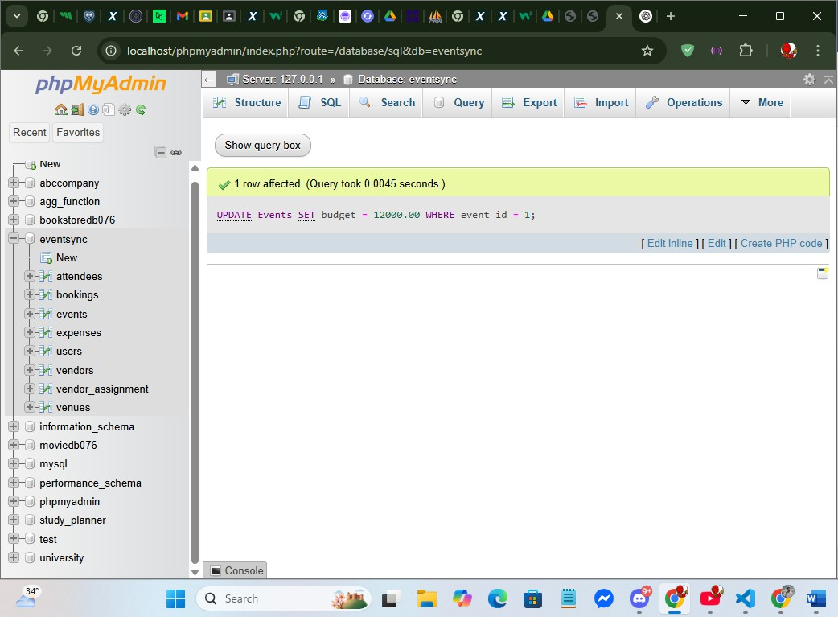

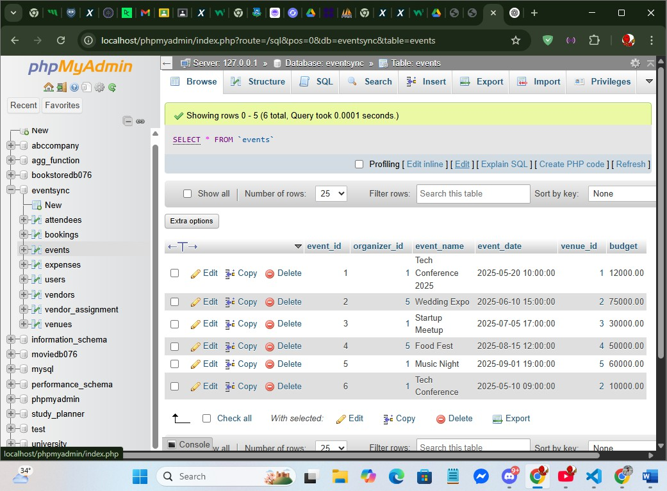

-- 4. Delete a declined attendee DELETE FROM Attendees WHERE status = 'Declined';

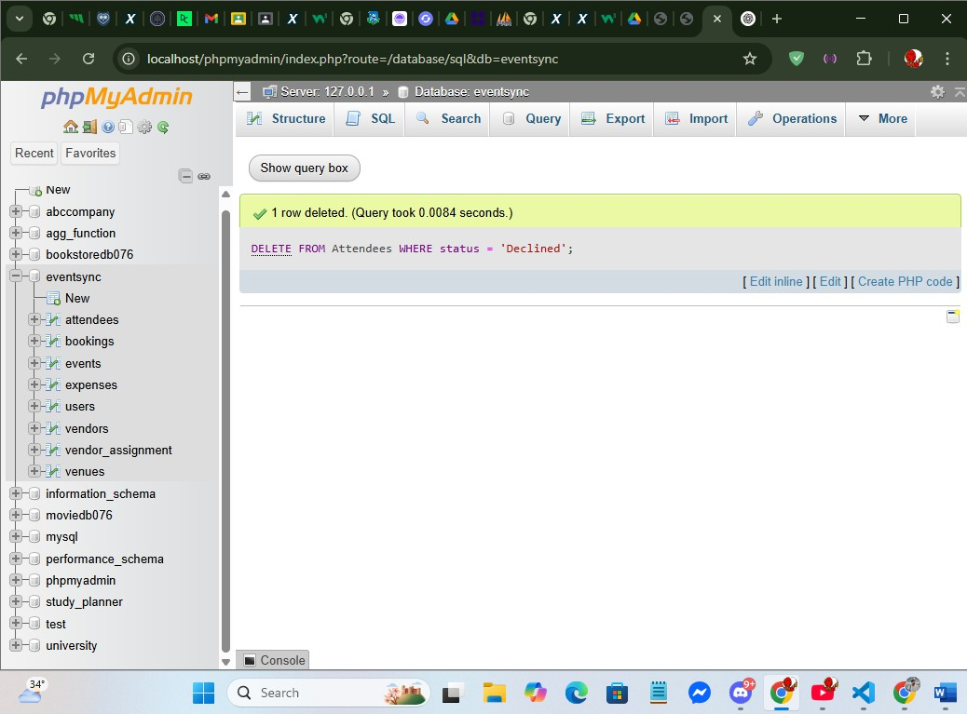

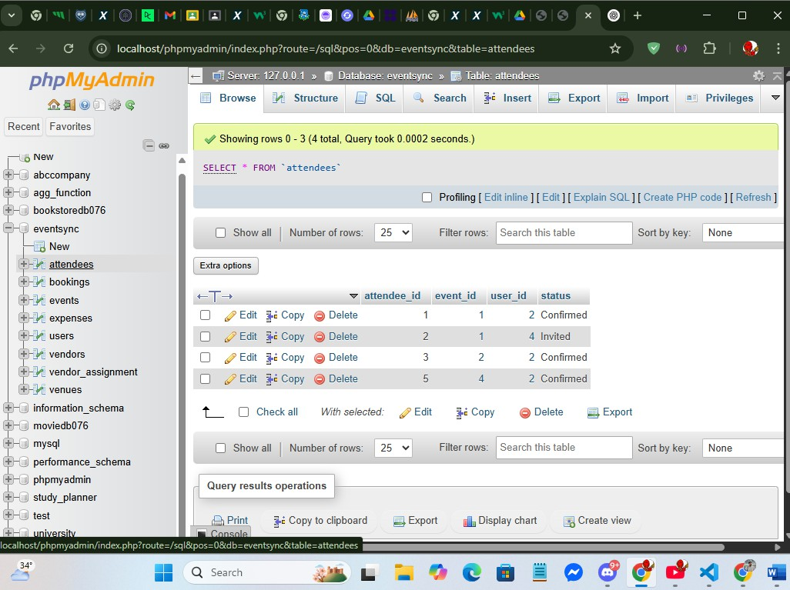

-- 5. Get all venues in New York SELECT *

FROM Venues

WHERE location LIKE '%New York%';

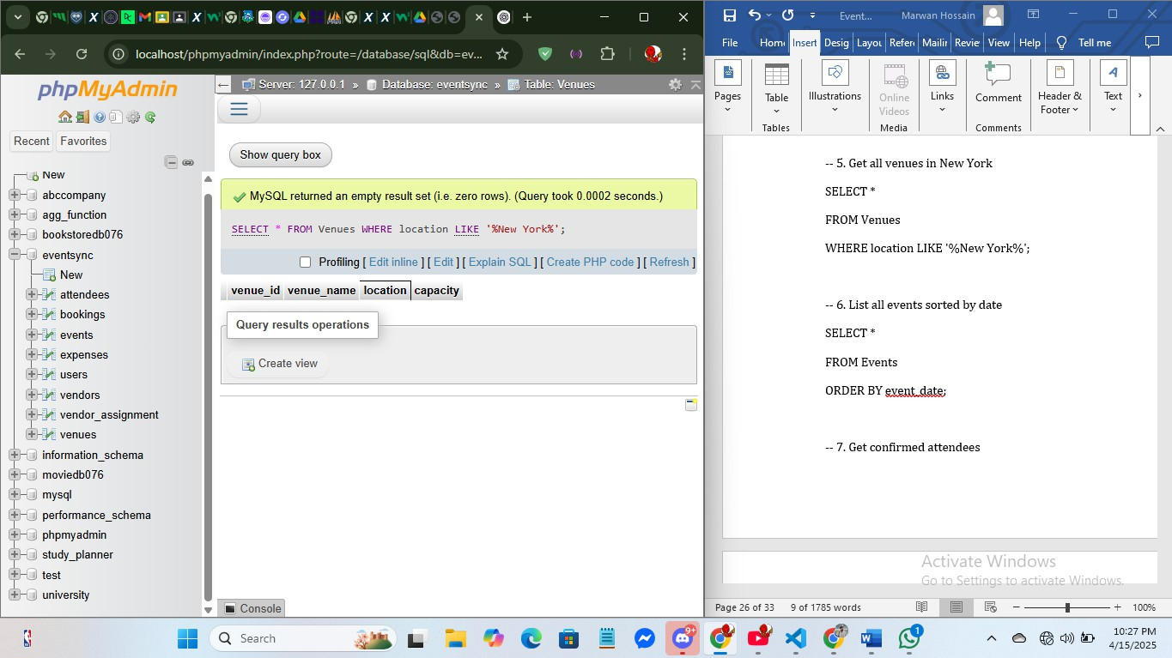

-- 6. List all events sorted by date SELECT *

FROM Events

ORDER BY event_date;

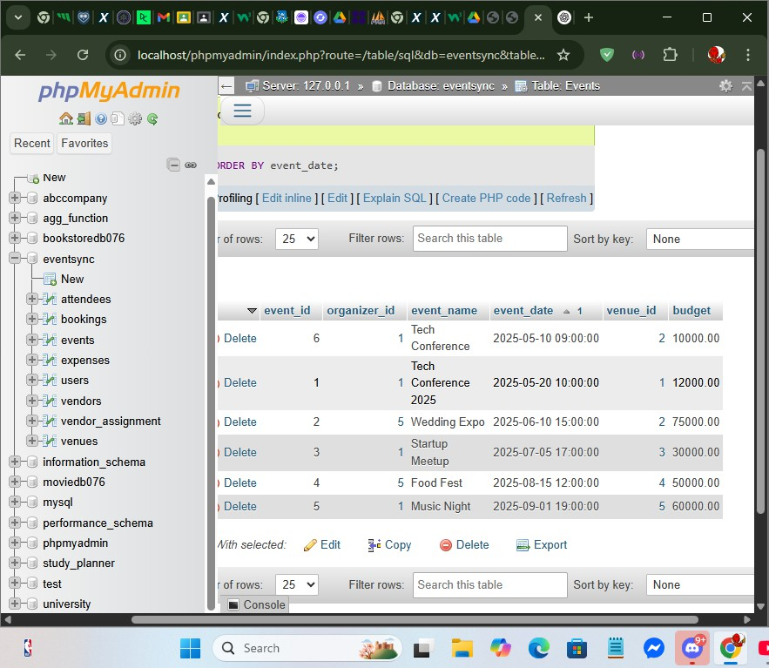

-- 7. Get confirmed attendees SELECT *

FROM Attendees

WHERE status = 'Confirmed';

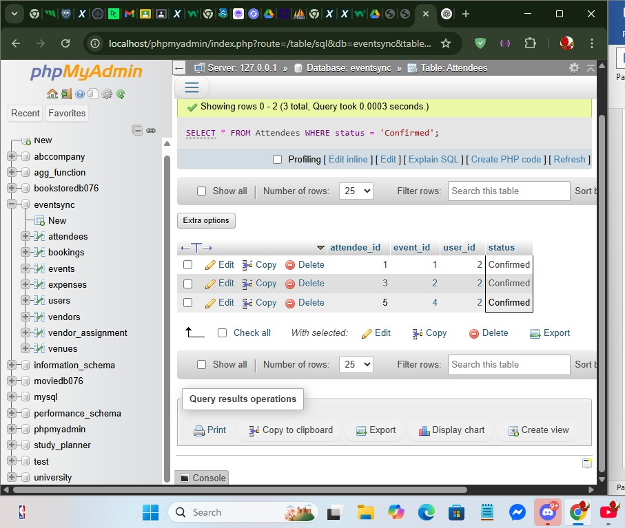

-- 8. Find users with Gmail SELECT *

FROM Users

WHERE email LIKE '%example%';

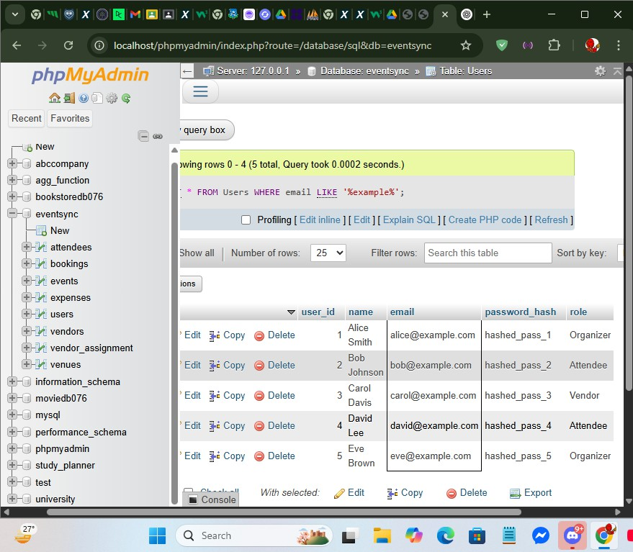

-- 9. Users from specific roles SELECT *

FROM Users

WHERE role IN ('Organizer', 'Vendor');

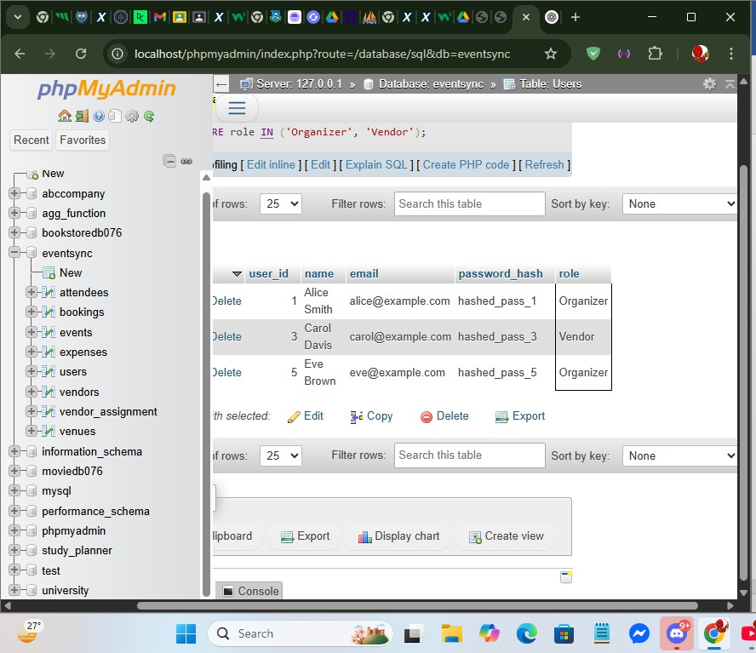

-- 10. Events within a budget range SELECT *

FROM Events

WHERE budget BETWEEN 5000 AND 15000;

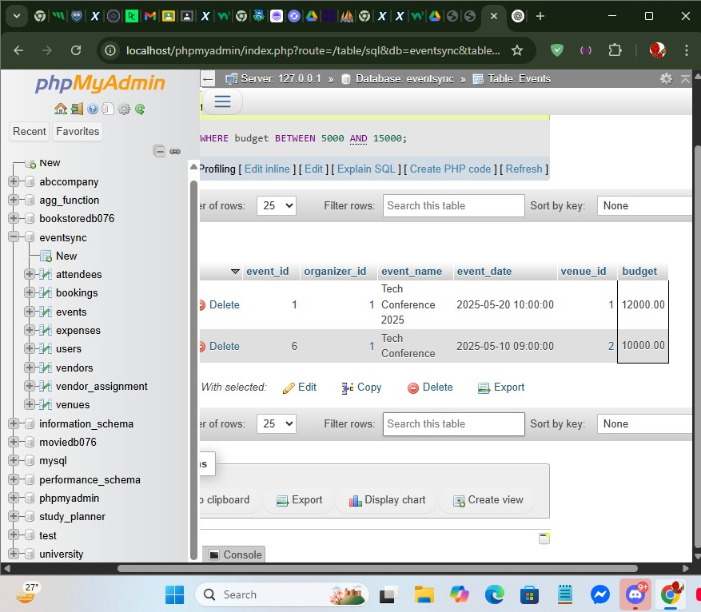

-- 11. Total number of users SELECT COUNT(*) AS total_users FROM Users;

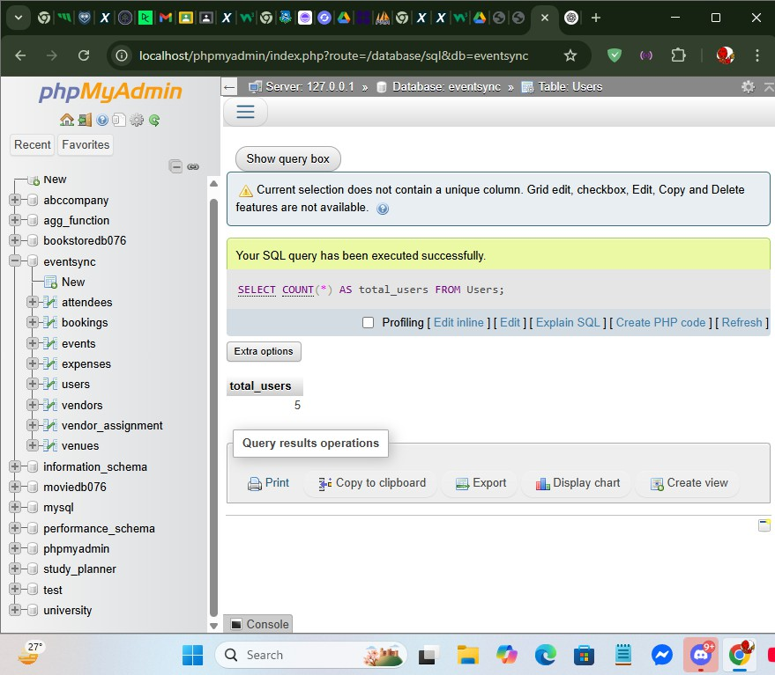

-- 12. Average event budget

SELECT AVG(budget) AS avg_budget FROM Events;

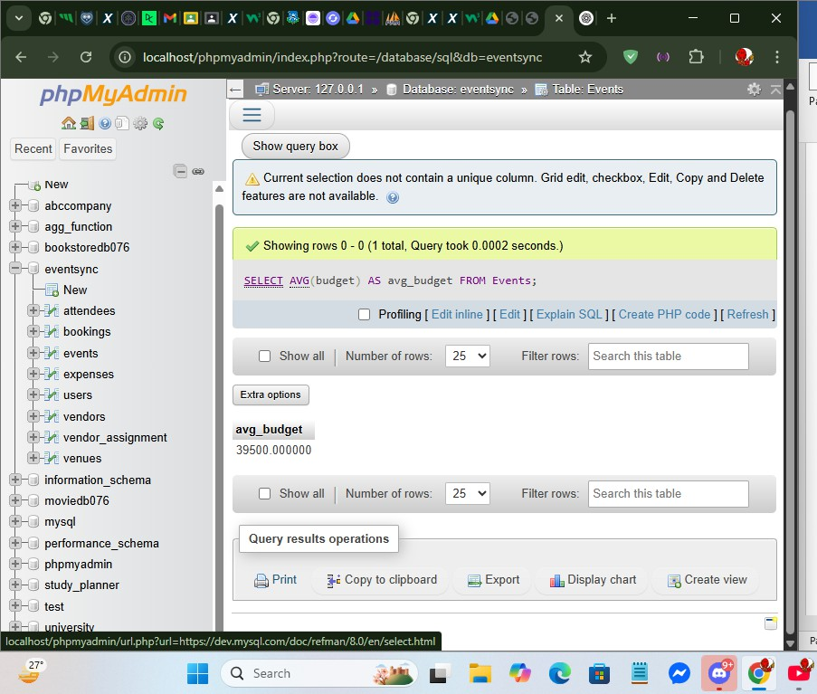

-- 13. Maximum venue capacity

SELECT MAX(capacity) AS max_capacity FROM Venues;

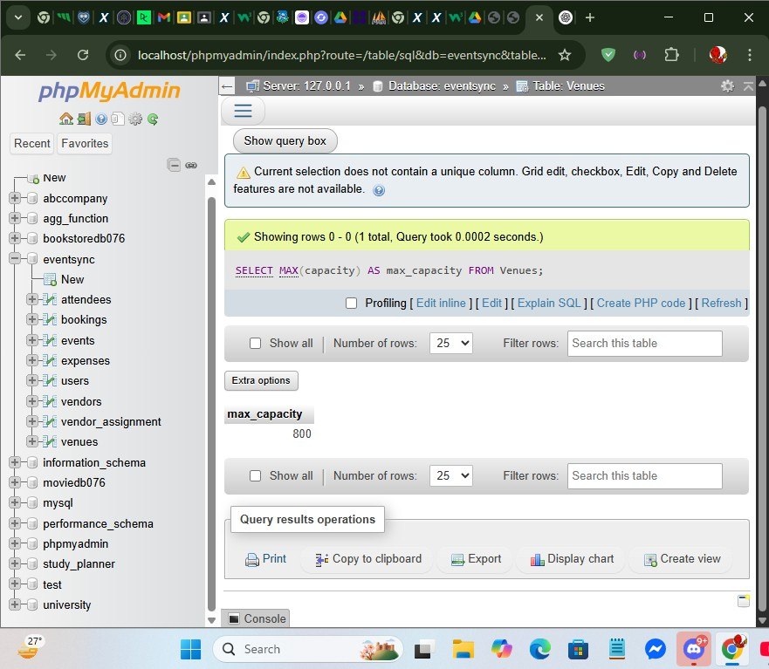

-- 14. Number of attendees per event

SELECT event_id, COUNT(*) AS attendee_count FROM Attendees

GROUP BY event_id;

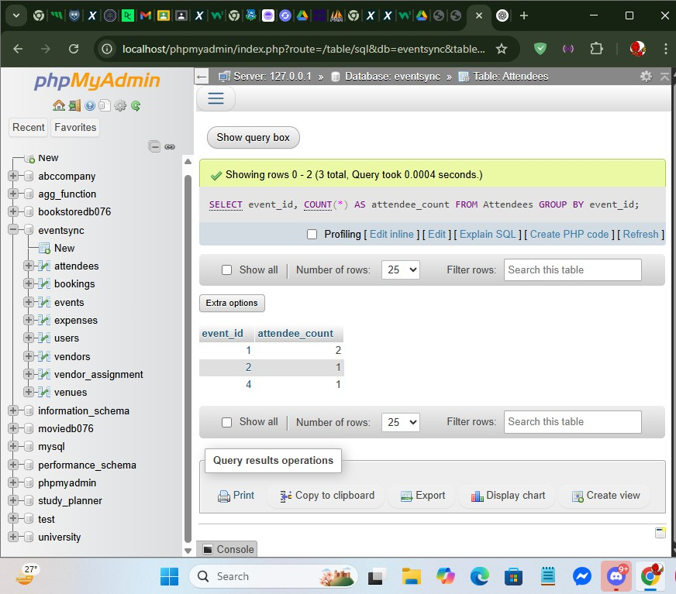

-- 15. Total bookings

SELECT COUNT(*) AS total_bookings FROM Bookings;

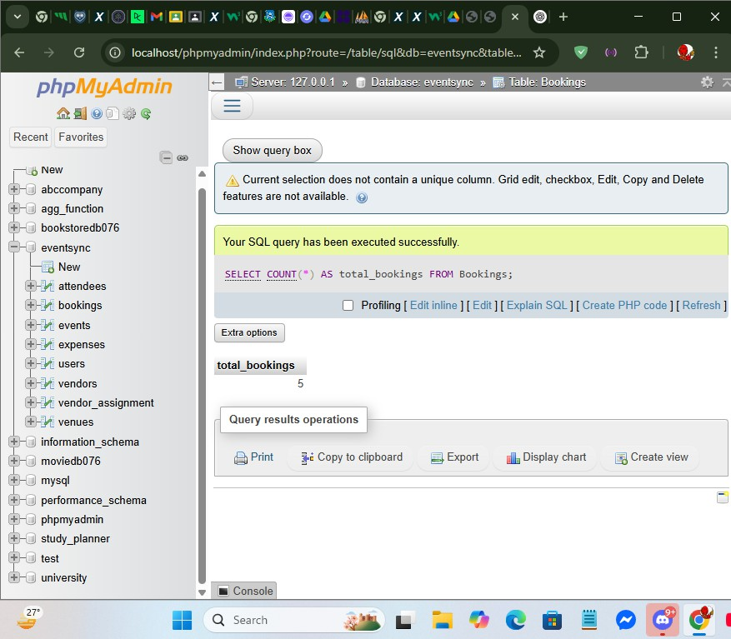

-- 16. Events with their venues SELECT e.event_name, v.venue_name FROM Events e

JOIN Venues v ON e.venue_id = v.venue_id;

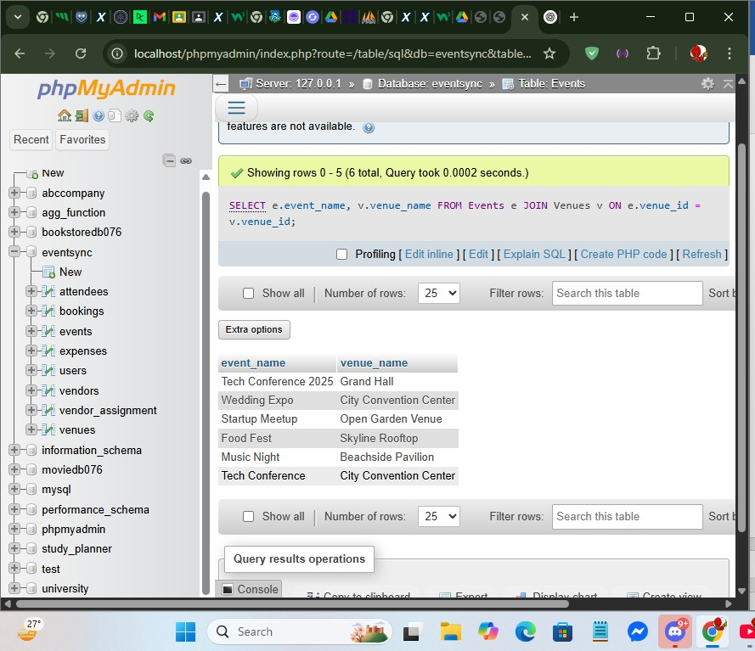

-- 17. Vendors assigned to events SELECT v.vendor_name, e.event_name FROM Vendor_Assignment va

JOIN Vendors v ON va.vendor_id = v.vendor_id JOIN Events e ON va.event_id = e.event_id;

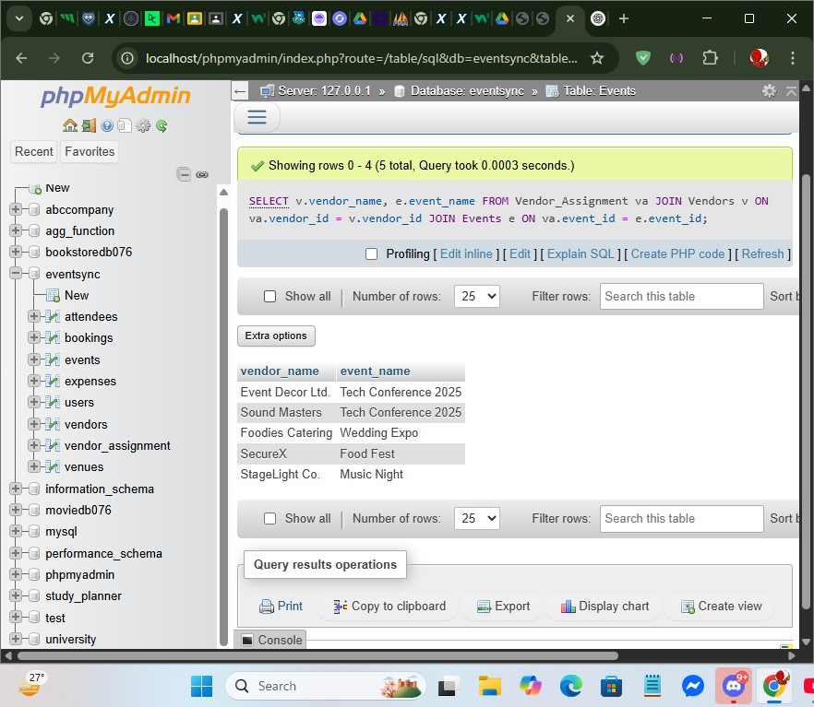

-- 18. Events without bookings SELECT e.event_name

FROM Events e

LEFT JOIN Bookings b ON e.event_id = b.event_id WHERE b.booking_id IS NULL;

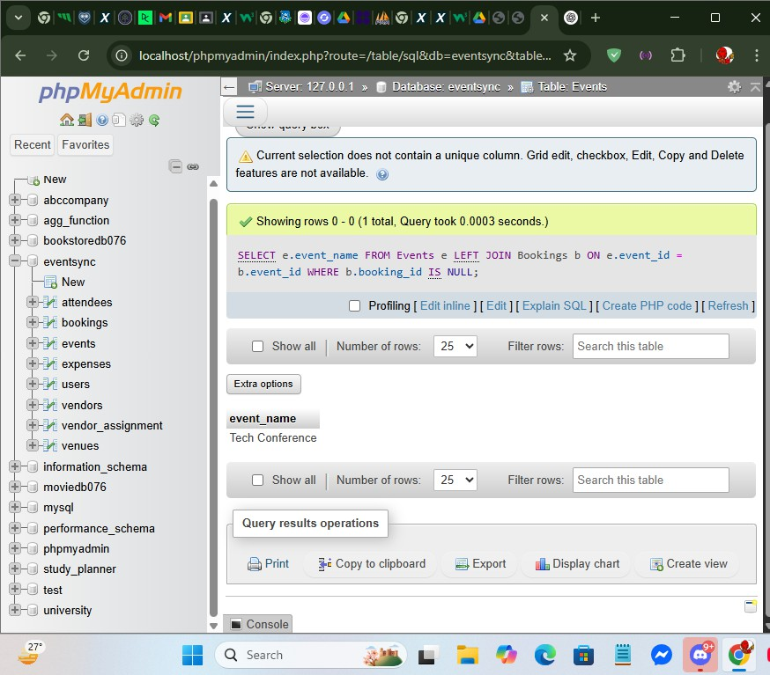

-- 19. Events and their organizers

SELECT e.event_name, u.name AS organizer_name FROM Events e

JOIN Users u ON e.organizer_id = u.user_id;

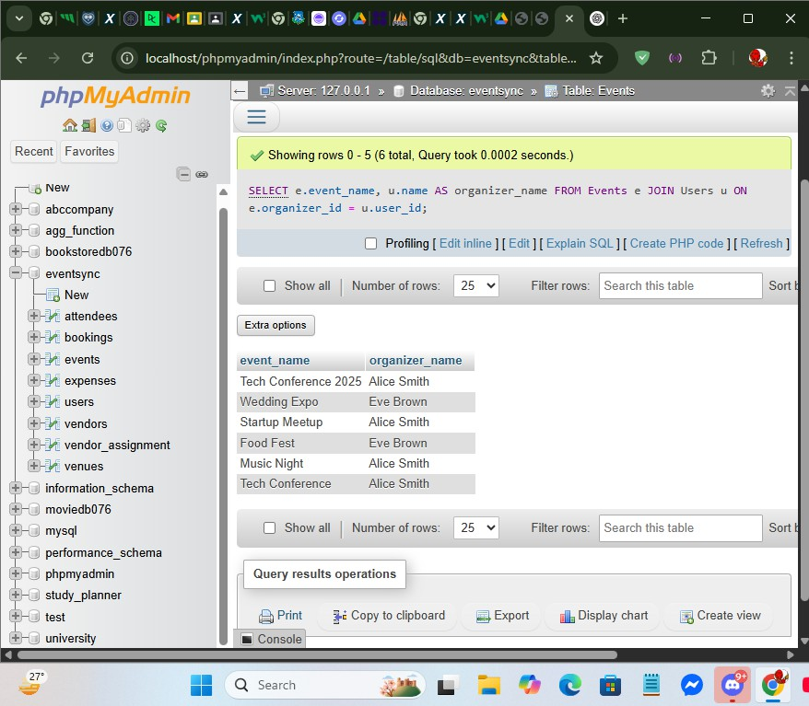

-- 20. Booking details with venue info SELECT b.booking_date, v.venue_name FROM Bookings b

JOIN Venues v ON b.venue_id = v.venue_id;

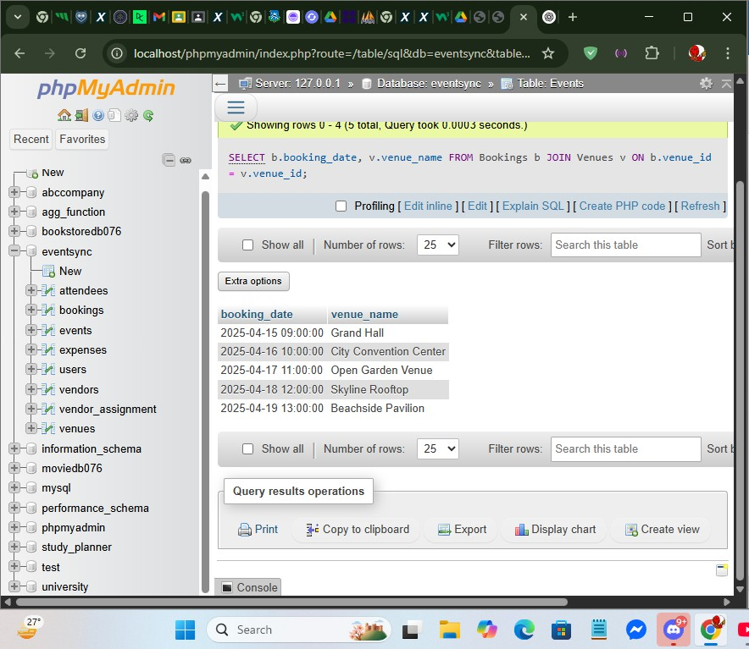

-- 21. Add unique constraint to contact_info ALTER TABLE Vendors

ADD CONSTRAINT unique_contact UNIQUE (contact_info);

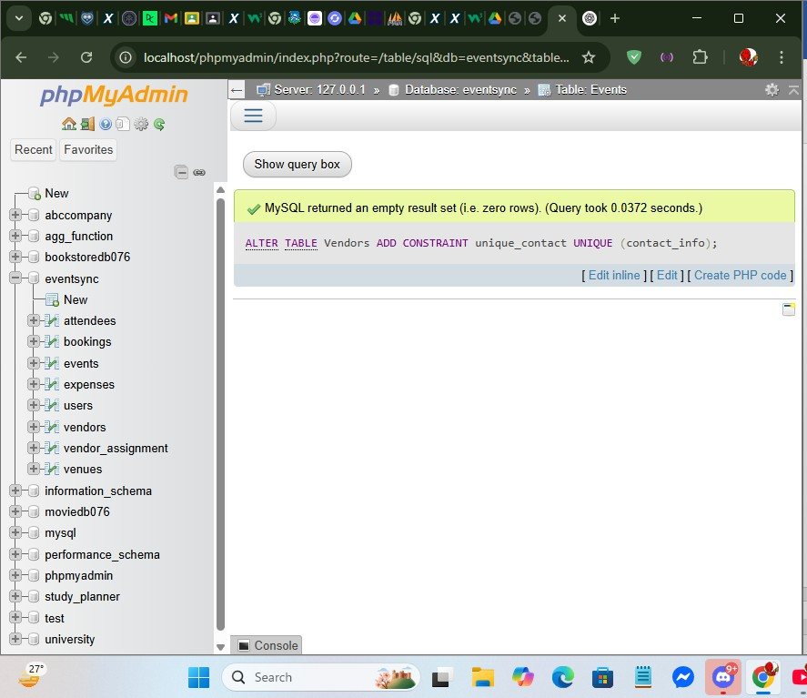

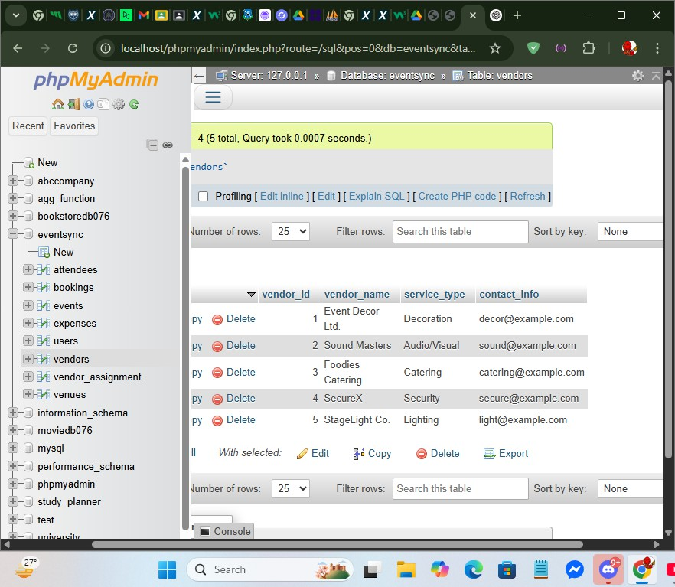

-- 22. Add foreign key to Vendor_Assignment ALTER TABLE Vendor_Assignment

ADD CONSTRAINT fk_vendor FOREIGN KEY (vendor_id) REFERENCES Vendors(vendor_id);

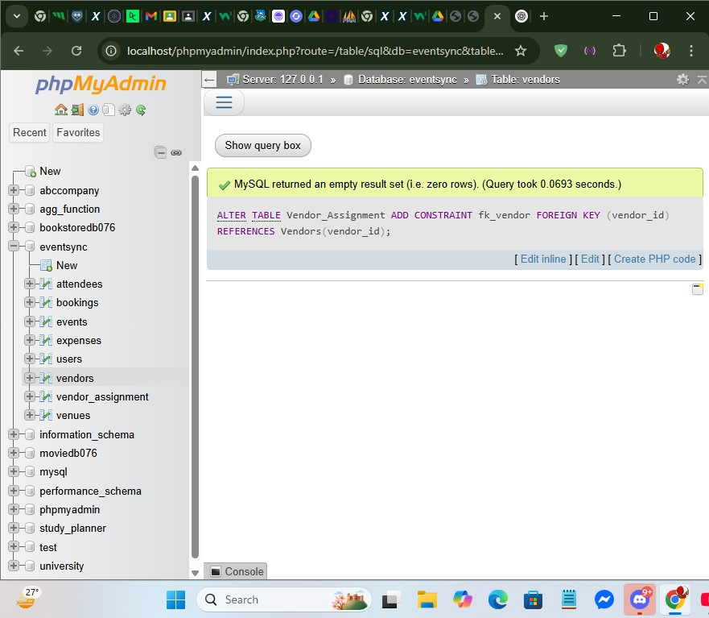

-- 23. Set user name to NOT NULL ALTER TABLE Users

MODIFY name VARCHAR(100) NOT NULL;

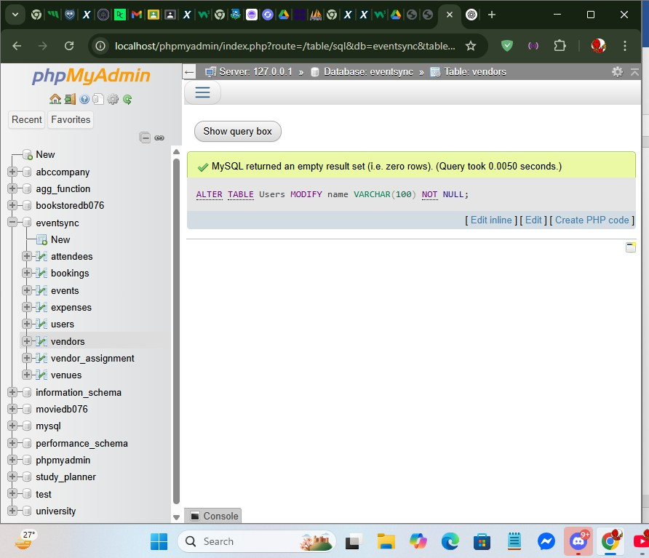

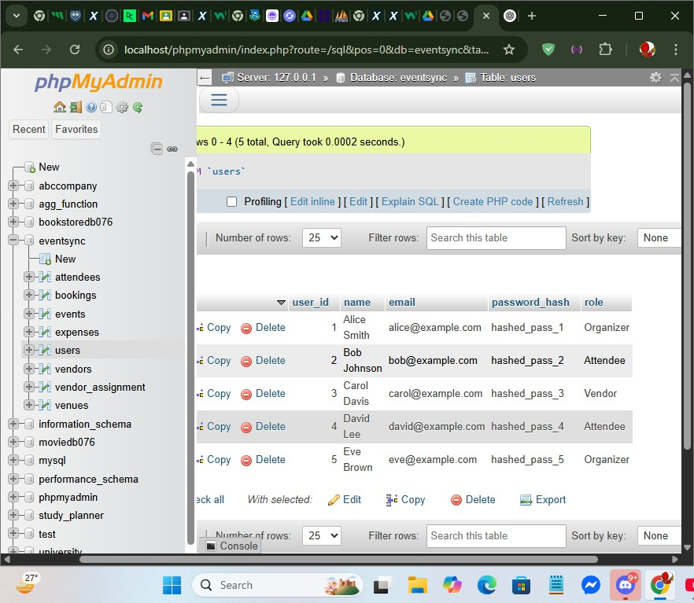

-- 24. Count events per organizer

SELECT organizer_id, COUNT(*) AS event_count FROM Events

GROUP BY organizer_id;

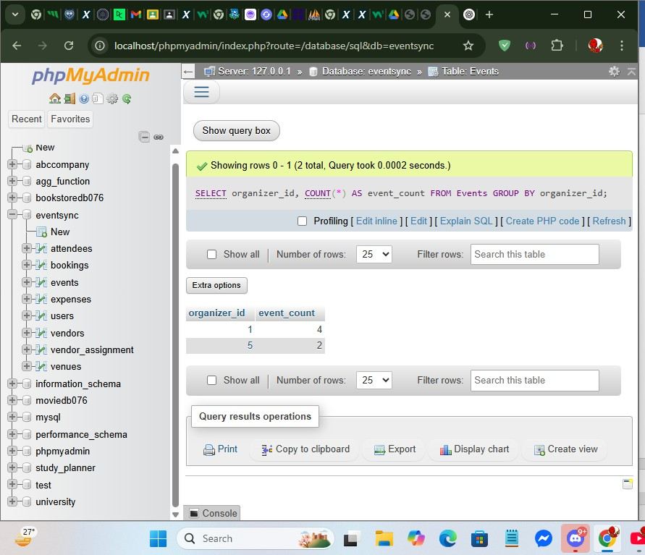

-- 25. Label roles using CASE SELECT name,

CASE

WHEN role = 'Organizer' THEN 'Event Manager' ELSE role

END AS role_label FROM Users;

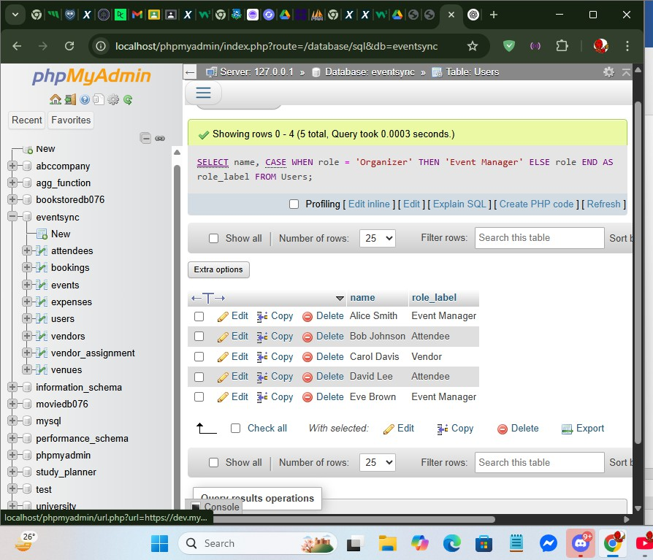

-- 26. Stored procedure to get events by user DELIMITER $$

CREATE PROCEDURE GetUserEvents(IN uid INT) BEGIN

SELECT event_name, event_date FROM Events

WHERE organizer_id = uid; END $$

DELIMITER ;

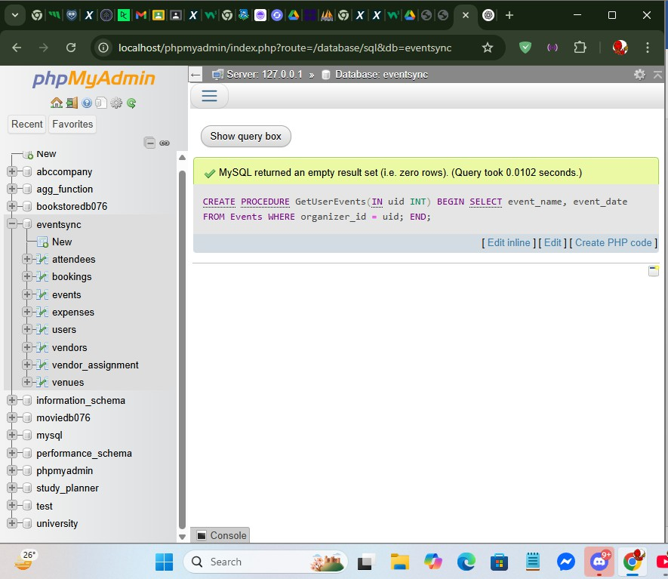

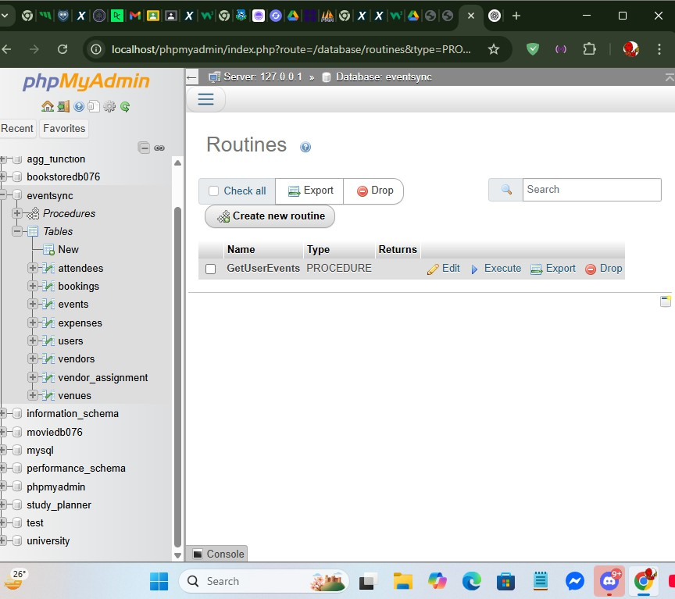

-- 27. Count NULL venues

SELECT COUNT(*) AS null_venues FROM Events

WHERE venue_id IS NULL;

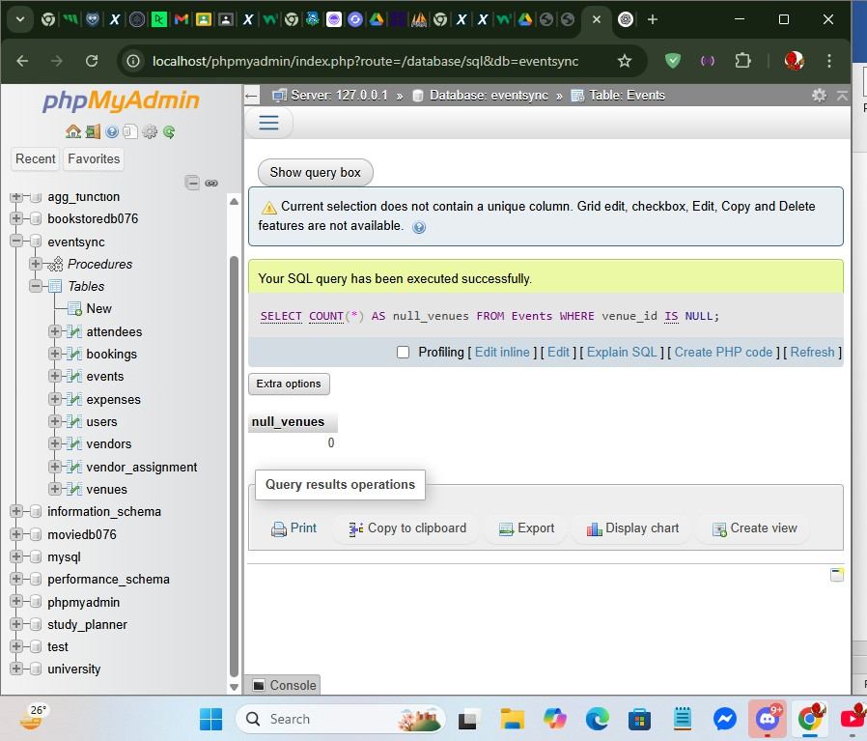

-- 28. Create index on location CREATE INDEX idx_location ON Venues(location);

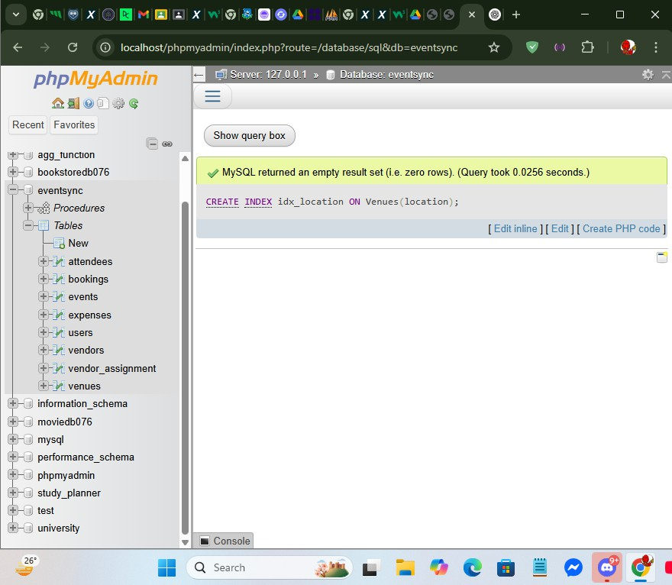

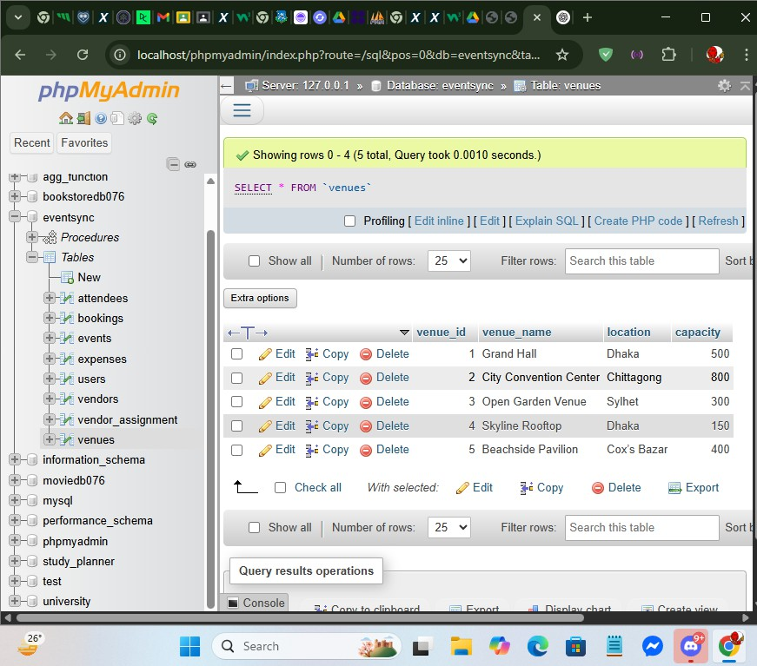

-- 29. Add phone column to Users ALTER TABLE Users

ADD COLUMN phone VARCHAR(15);

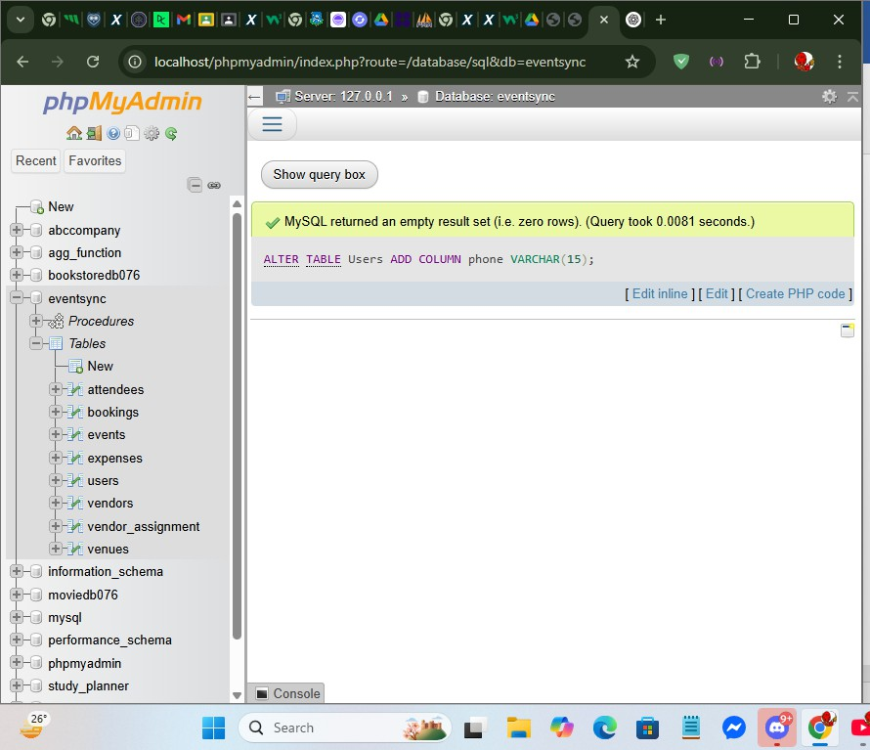

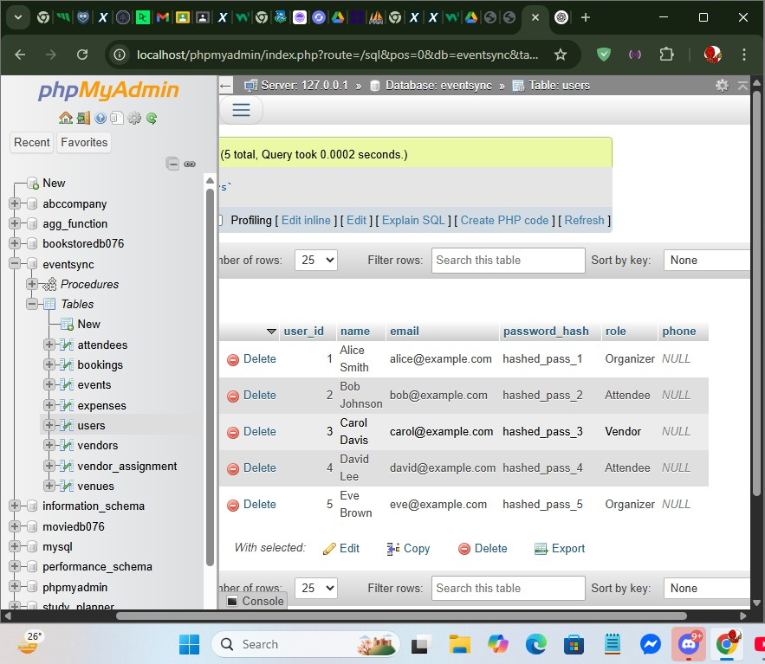

-- 30. Add assigned_date to Vendor_Assignment ALTER TABLE Vendor_Assignment

ADD COLUMN assigned_date DATE;

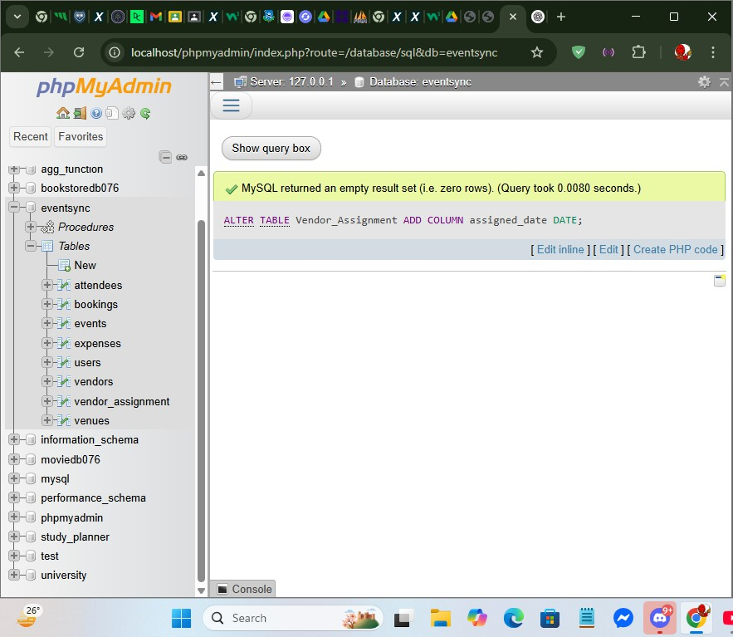

-- 31. Create view of event budgets CREATE VIEW EventBudgets AS SELECT event_name, budget FROM Events;

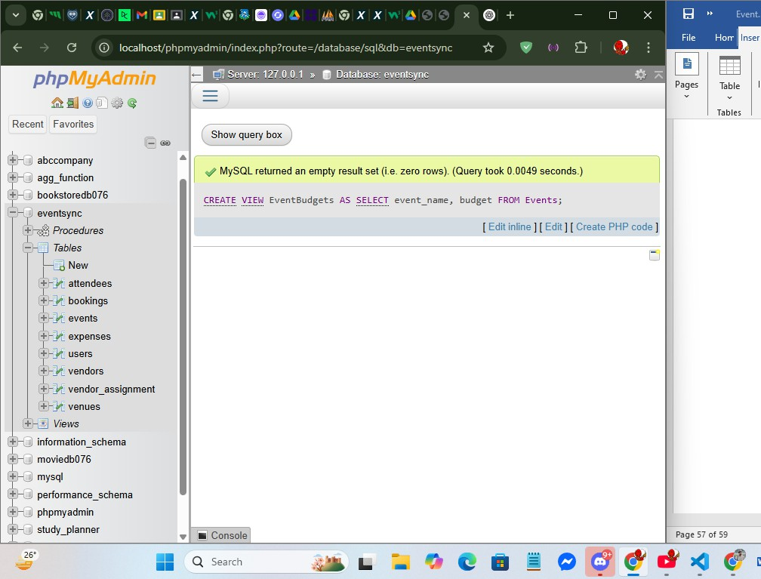

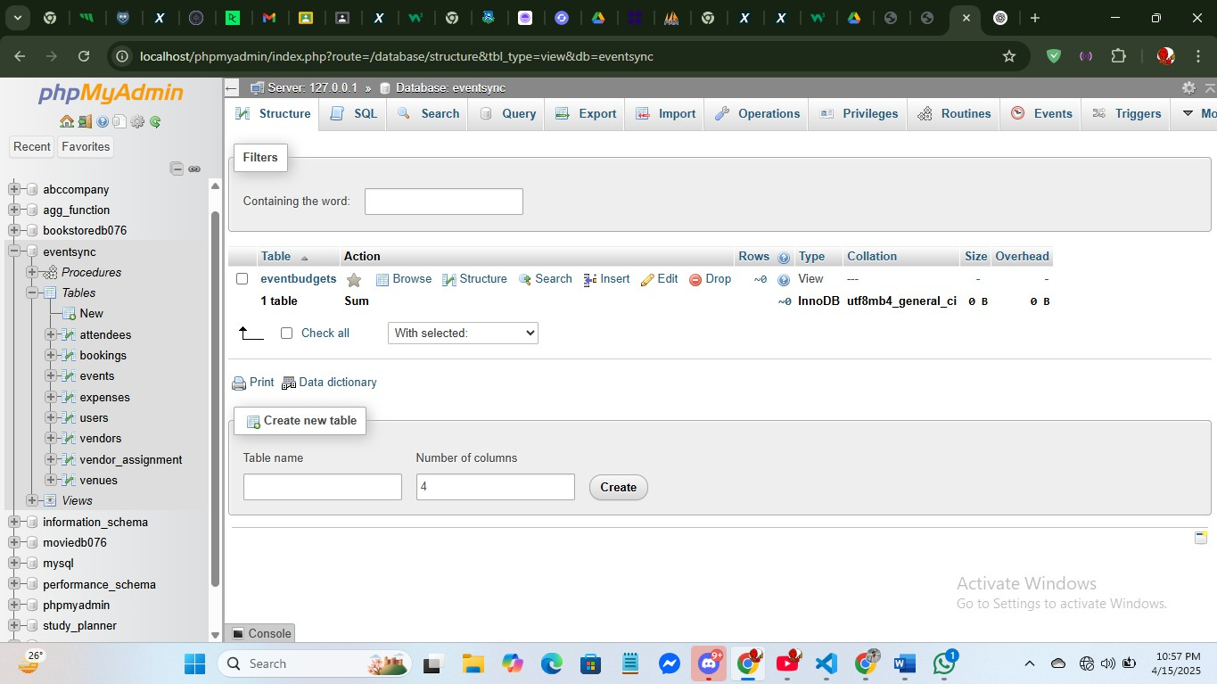

-- 32. Query view for high-budget events SELECT *

FROM EventBudgets WHERE budget > 10000;

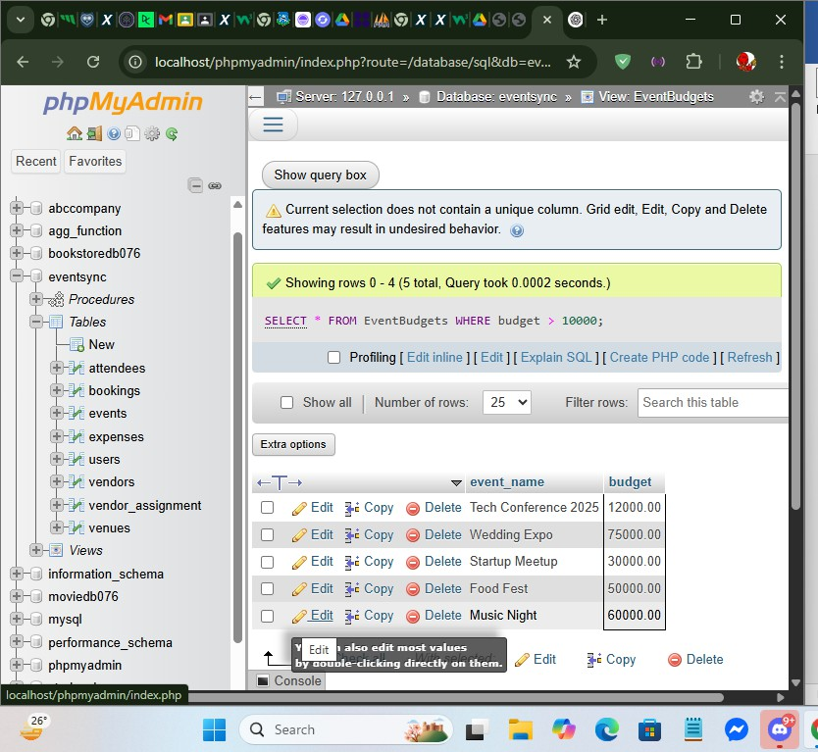

-- 33. Prepared statement example PREPARE stmt

FROM 'SELECT * FROM Users WHERE email = ?';

SET @email = ['admin@example.com';](mailto:%27admin@example.com) EXECUTE stmt USING @email;

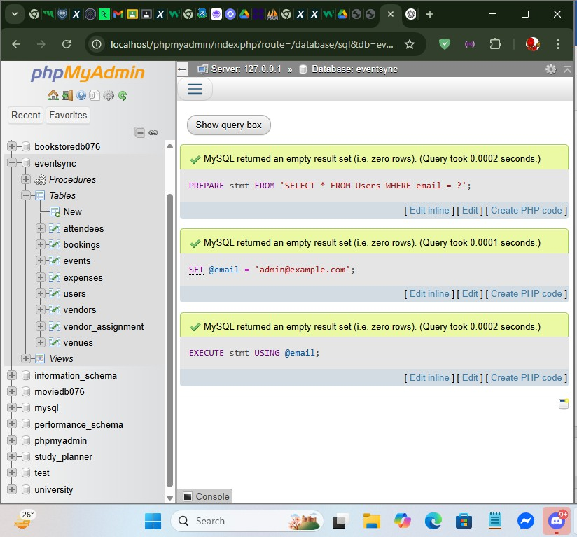

-- 34. List user names and roles SELECT name, role

FROM Users;

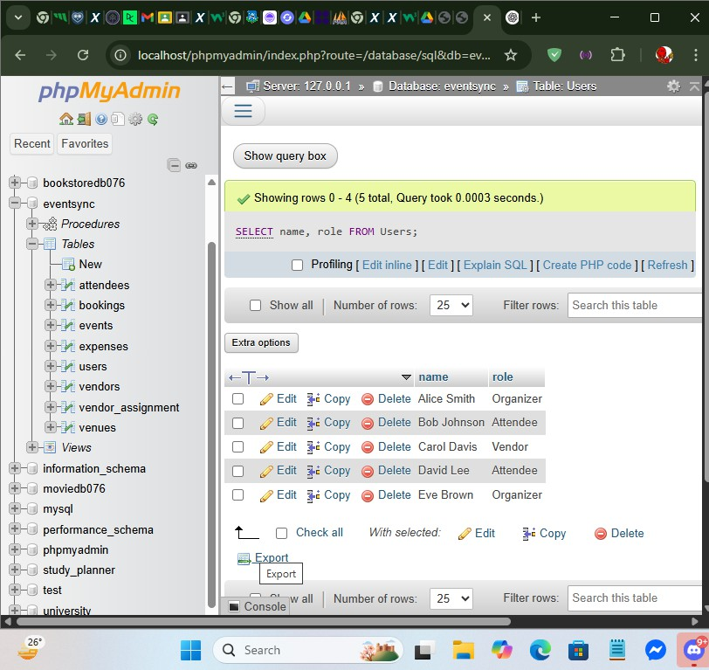

-- 35. Events with more than 5 attendees SELECT event_id

FROM Attendees GROUP BY event_id HAVING COUNT(*) > 5;

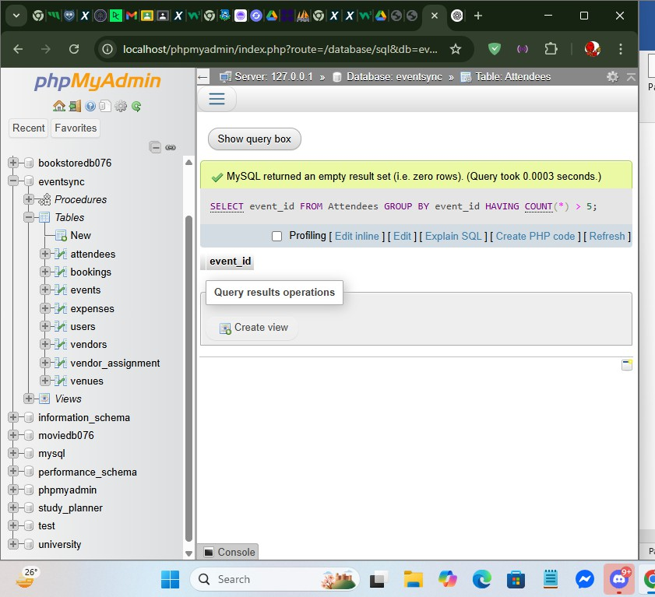

-- 36. Most popular venue

SELECT venue_id, COUNT(*) AS booking_count FROM Bookings

GROUP BY venue_id

ORDER BY booking_count DESC LIMIT 1;

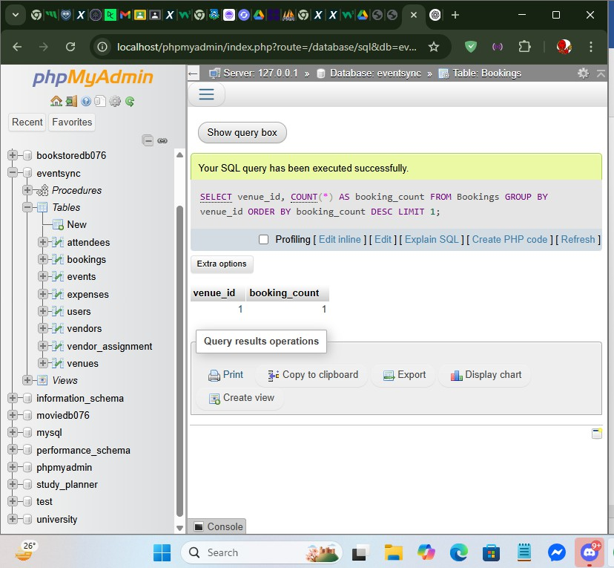

-- 37. Events with latest booking

SELECT event_id, MAX(booking_date) AS latest_booking FROM Bookings

GROUP BY event_id;

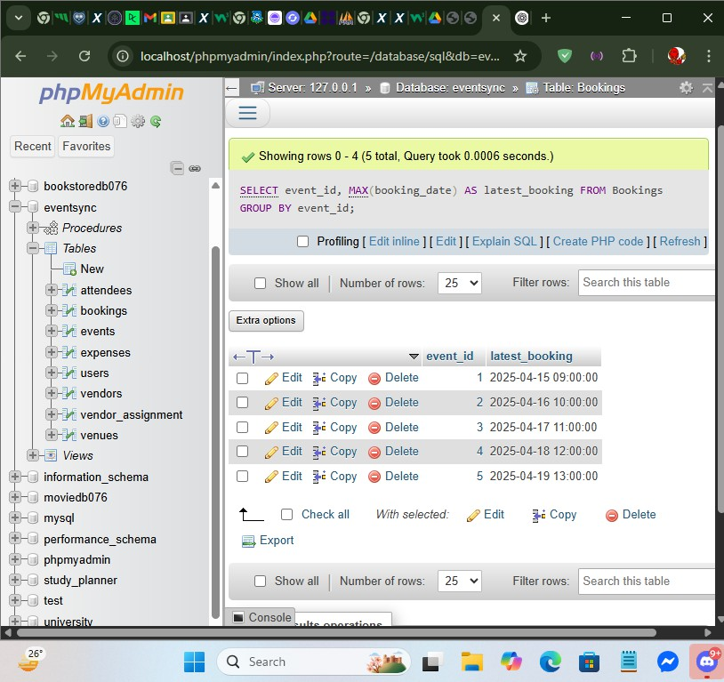

-- 38. Vendors with multiple assignments SELECT vendor_id, COUNT(*) AS total_events FROM Vendor_Assignment

GROUP BY vendor_id HAVING total_events > 2;

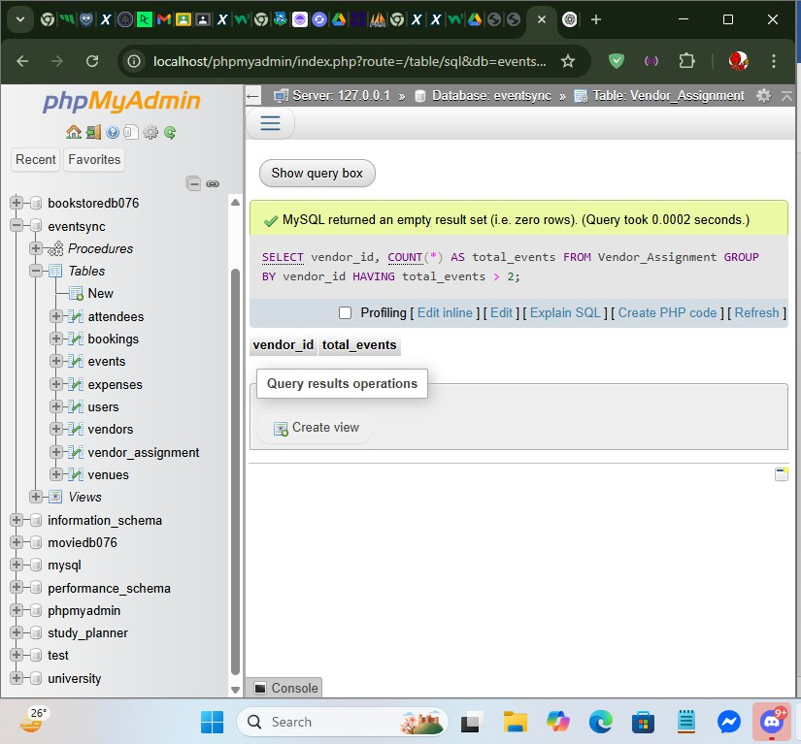

-- 39. Average expenses per event

SELECT event_id, AVG(amount) AS avg_expense FROM Expenses

GROUP BY event_id;

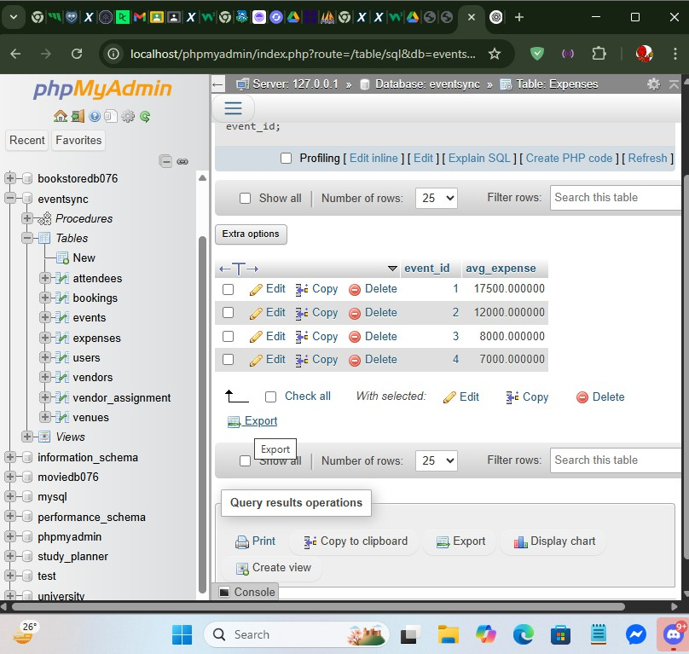

-- 40. Events with no expenses SELECT e.event_name

FROM Events e

LEFT JOIN Expenses ex ON e.event_id = ex.event_id WHERE ex.expense_id IS NULL;

